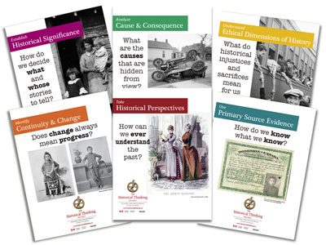
Historical Significance and Historical Perspective
Explore | Your Task
- Explore the Google Slide and head to the following padlet to share what you have seen.

- After watching the following videos what is more significant - winning a gold medal in the Olympics or winning the Stanley Cup?
Head to Flipgrid to record your response

Explain | Your Task
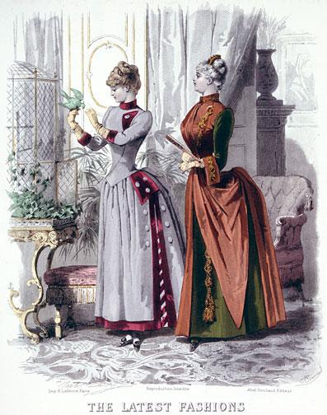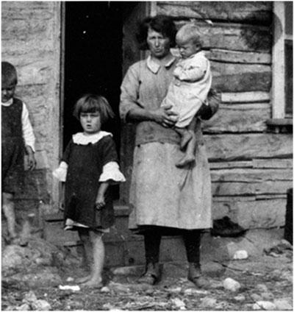  . | After watching the following videos post your answer in the following Google Doc and upload your response into your Google Classroom assignment.  - In the video for historical significance, what are the criteria for determining the significance of an event?  - In the video for historical perspective, what are the two key questions that help us address perspective and what key word is attached to each question?
Apply | Your Task
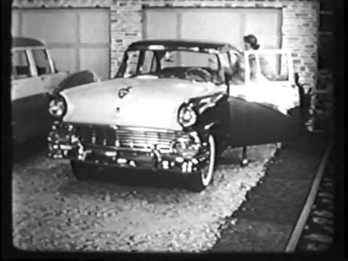 | Using the criteria from the Historical Significance videos, rank these five events in order of significance..  Knowing about presentism and stereotyping, how do they impact your interpretation of these clips.  Head to the following  to post your rankings and thoughts around your interpretations of the clips with a partner..
Template used from Teachers Give Teachers
Hyperdoc created by :
Stephanie Gardner, Kathy Yurek, Shelia Fleming, Trish Pearson, Jennifer Duckworth-Rispin

