Continuity and Change

Engage
Examine the following SLIDE DECK - what do notice that stays the same and what has changed? Jot your ideas on a post it note and be prepared to discuss

Explain
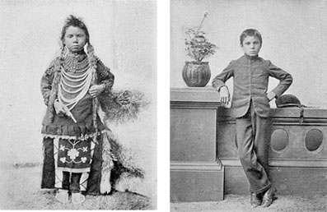
“The more things change, the more things remain the same”

After watching the following video answer the the following Google Doc and upload your response into your Google Classroom assignment.
What are the questions that need to be considered when looking at continuity and change? Be sure to explain in your own words.

Apply
Create a photo timeline by placing the package of pictures in what you think is the correct chronological order. (Be sure to get the package of pictures from your teacher)
Which image demonstrates a notable turning point in the course of the history of phones?
How might this change reflect or impact the lives and conditions of this time?
Click HERE for phone photos you can use in your presentation

Create an video with your timeline and an be sure to explain your answers to the questions.

Share
Head to the following padlet to share your Adobe Spark Video, be sure to comment on two other videos - be sure to use the guiding questions for continuity and change when you are giving feedback.

Reflect
Thinking about your life from kindergarten to now - how has your life stayed the same and how has it changed over time? What do you think is the biggest change and the main constant?

Extend
Create your own timeline of items that have changed. Use the original slide deck as inspiration. Be sure you use the criteria when making your decision. Head HERE to create and share your work.
Template from Teachers Give Teachers
Hyperdoc created by: Stephanie Gardner and Kathy Yurek

