Cause and Consequence

Engage
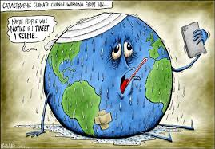
Head to Today’s Meet and “tweet” your reply as to what you think this comic means.

Explain
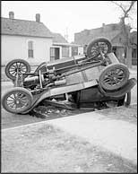
“Why do events happen and what is their impact?”

After watching the following video answer the the following Google Doc and upload your response into your Google Classroom assignment.
What are the factors and questions that need to be considered when looking at cause and consequence? Be sure to explain in your own words.

Apply
Change the World in 5 Minutes
Watch the following video and choose one idea. Apply the criteria for cause and consequence and determine possible causes. What could be the short and long term impacts of these ideas? Use Screencastify to record your answers.
Watch the following tutorial to see how to use it.

Share
Head to the following to share your work and click HERE to view others.

Extend
Thinking about what you know about Cause and Consequence what idea could you come up with to change the world in 5 minutes everyday at school. Head HERE to create and share your work.

