Canada and Global Issues
The highlighted text is teacher notes that will need to be removed before sharing the document with students.

Engage
Click the image and watch the video
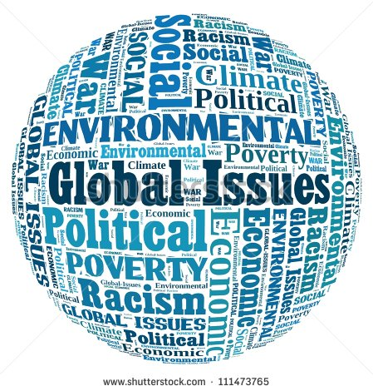

Thinking about yourself and your community what are the top 5 issues from the video you think Canada should be concerned about. Record your rankings on this Padlet.

Teacher notes: View the completed Padlet as a class. As students share the issues, the teacher writes the issue on a sticky note and sorts them on the board in the following categories Human Rights, World Health, Economy and Trade, Disaster Relief and the Environment. Students will then have to come up with the titles for each category.

Explore
Human Rights- UN
World Health- WHO
Economy and Trade- NAFTA
Disaster Relief- DART
Environment- WWF
As you read, record your findings on the page provided.
Teacher notes: Premade page including guiding questions. Resources used from Nelson Social Studies

Explain
Use Google slides to present your information to your classmates. Go to our Google classroom for the assignment.

Apply
Our job now is to think about where we would rank them from most to least effective. Now before you do that let’s think about this criteria:
Relevance based on current issue?
Number of people that the organization impacts?
Cost to Canadians?
Lasting impact on the Global Community?

Teacher notes Record your rankings on a premade rocket book. Repeated ranking of options from Using thoughtbooks to sustain inquiry.

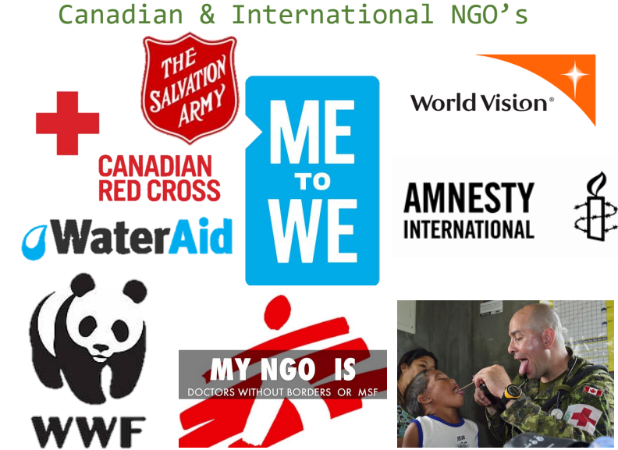 | But wait there’s more...
Direct teaching on NGO’s . What other organizations does Canada have that support the global community?
Human Rights: L’Arche Canada
World Health: Canadian Red Cross or Doctors Without Borders
Economy and Trade: Habitat for Humanity (Affordable Housing)
Disaster Relief: Canadian Red Cross or Save the Children
Environment: Greenpeace Canada or WaterAid

Continue to think about the criteria we discussed
Current issue?

Apply
Now that you know more. You work for the government and it is your job to choose two organizations to cut due to funding limits. Which ones would you support/cut remembering the criteria discussed.
Using the rocket page provided, complete your ranking based on new evidence. Compare this to your original ranking. How has your thinking changed? Explain your thinking providing evidence to justify your answer.

Teacher notes: Repeated ranking of options from Using thoughtbooks to sustain inquiry. Include thinking around NGO support as well.

Share
Share results and as a class come up with a class consensus. Think about the criteria established to make the final class decision.

Reflect
What is the consequences of your decision both long term and short term to Canadians and the Global community?

