Canadian History 1713-1800 Causes and Consequences
What type of forces can bring about change? Examining the cause and consequences of events in history.
Teacher notes are highlighted in yellow (please make a copy and erase teacher notes before giving to students)
Engage | What makes something a force? What forces bring about change?  Develop a criteria in padlet  Teacher criteria to facilitate conversation: a push that brings about change in a positive or negative way  Has a long lasting effect  Did it have a cause or consequence?
Explore | Synopsis on main events - rank and order - (The Treaty of Utrecht, The Seven Years’ War, Expulsion of the Acadians, The Battle of Plains of Abraham, Pontiac's Rebellion, Loyalist Migration)  While you are ranking and ordering be sure to add in Opportunities, Challenges and I Wonders for your top choice. *Physically in the room - rank and order - one ladder/different post its* Put post its on Rocketbook pages - submit OCI to Google Classroom*
Explain | See your Teacher for your Explain package. Go deeper into articles/background information (use resources from TC2, text books to provide students with additional information, and rank and order again using your force, and also your cause and consequence criteria.  *Review cause and consequence criteria - video is linked*  Use Adobe Spark for your new Rank and Order. Be sure to submit to Google Classroom.
Elaborate | Rank and Order Ladder - which of these events had the greatest consequences for the following groups  First Nations, Church, Fur Traders, British, Acadians, French, Women Students will explain their responses in Flipgrid, be sure to create a new Flipgrid account for your students
Evaluate | *Students will be assigned a perspective* Looking at ladder again with your Group - reorder events from the perspective of your chosen group. What were the short and long term impacts of the event and is it still felt today?  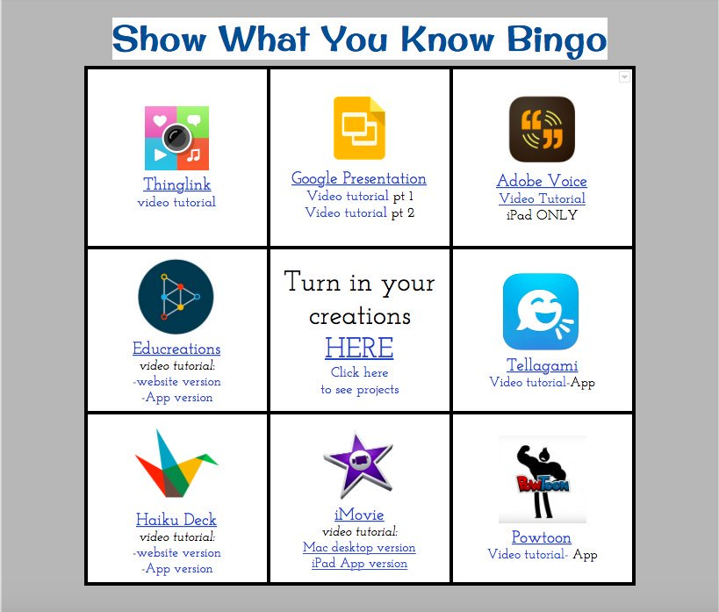  Be sure to review the success criteria before you submit your show what you know.  Complete your self reflection form (Create a new copy of the self reflection form and change the link)

