Extensions for Vertical Gardens
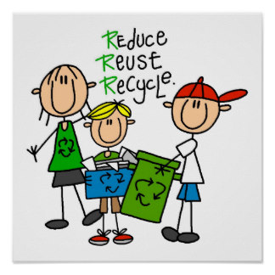
The vertical garden Innovation Project is a great springboard for many other links to the Ontario Curriculum as well as Current Events and Environmental Stewardship.

1.Reduce Reuse Recycle
By being an active participant in collecting bottles, students are becoming an important part in their own reduce, reuse and recycle program. This is just one of the ways that our students can be exposed to real ways to be stewards of the Earth.
Reduce Reuse Recyle image courtesy of: https://www.zazzle.com/reduce+reuse+recycle+posters

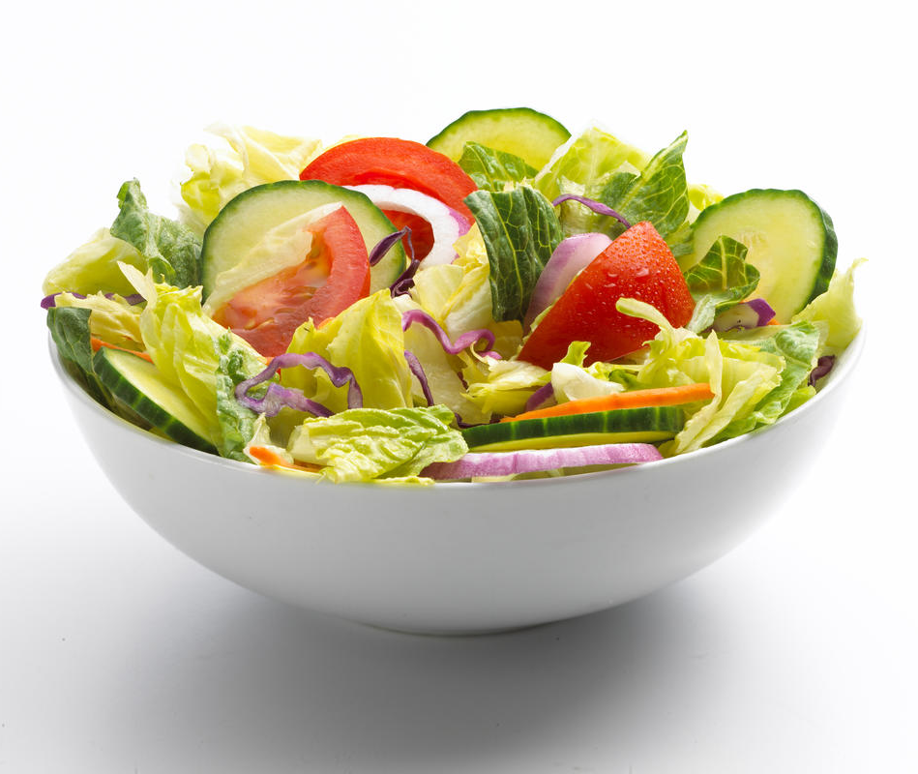
2.Healthy Living
Each of our vertical gardens are creating a salad! This salad can be used as a link to the Healthy Living strand and the importance of good nutrition. This can also highlight the connection between poor nutrition and health problems such as obesity; linking what we eat, to what our body needs to function properly and stay healthy. Highlighting the vitamins and minerals that are found in ‘greens’ can extend to other nutrients found in carbohydrates, proteins and fats and then ultimately to a healthy child!
Garden Salad image courtesy of: https://www.oregoncc.org/file/474

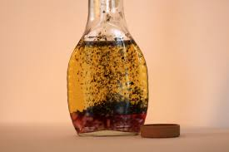
3. Link to Community Groups
Many community groups can be contacted to extend this unit. We contacted Adoro Olive Oils and Vinegars, and they were willing to come into the class to allow students to sample various oils and vinegar combinations with lettuce and bread. This will allow many students to experience something they may not have had before and create excitement about the combinations they will use for their own salads they are growing.
Oil and Vinegar image courtesy of: http://www.keywordsuggests.com/kSA*xjBW3FguggCA5rQwkY13fHgaQCFxvzyBv%7CoVR62*SlTGrKhpOrSjtTUv2yBGJmmfktMiM70NXyVp6aj0xA/

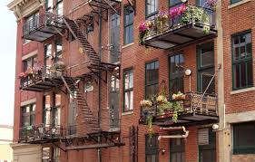
4. Inclusive for all incomes and living situations
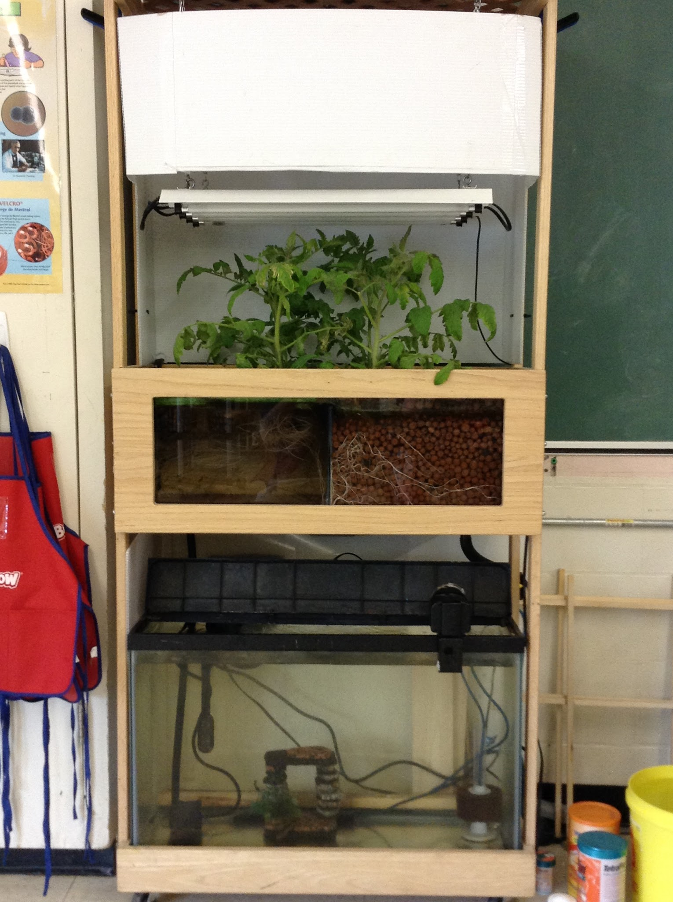
Vertical gardens allow students to create a garden even when they do not have a yard available, such as those in an apartment complex. With the increasing cost of produce it can sometime inhibit families from buying these healthy options. Creating our vertical garden from recycled items, limited income families still have access to this as an option. Talking to the students about harvesting seeds from each of the plants would also allow this garden to be viable for years to come with no additional cost.
Balcony image courtesy of: http://unsafeproducts.com/household/apartment-balcony-railing/

5. Aquaponics
As a class, you could create and aquaponics integrated system using aquaculture (raising fish) and hydroponics (the soil-less growing of plants). By using fish wastes to ‘feed’ the plants and the plants used to filter the water, a closed and sustainable garden is being achieved. Please note that this can be as simple as floating a styrofoam plant raft in a regular aquarium, or trying an experiment by hanging some vertical gardens over an aquarium and irrigating them with water from the fish tank to see if that will work just as well (water flows back into the tank as it leaves the bottom bottle).

6. Mathematics
Primary Data can be collected throughout the growth of the plants. Dissolved salts and pH can be measured at prescribed intervals and these results can be graphed and analysed, using a spreadsheet program such as Google Sheets, at the end of the project.

