GEOTRICITY 3.0

GUIDING STATEMENT: By being stewards and agents of change we can create liveable and sustainable communities.

CHALLENGE: Design a sustainable and liveable space in the school yard for the school community and the community at large.

TEAM MEMBERS:___________________________________________________

STEP 1: BRAINSTORM AND GUIDING QUESTIONS

The following questions are provided to help you complete the next page:
- What are some possible uses of the space?
- What does your community need/want? What will make the community excited and engaged in your project? Do you already know about something your neighbours would like to have? Have you seen something in another neighbourhood that you know your community will love?
- What does your planned use of space need? Consider the infrastructure (under the surface and behind the scenes systems that will make your plan work). Think about cost to build and maintain, ergonomics, types of long term maintenance and support it will need, safety, etc.
- How will you sell this to your peers and their families? What makes this idea great?
- What sets your idea apart from any other potential plans? If someone else has a similar concept, what will make yours the best possible choice?
- How can you connect ideas from land use from the community to ideas in the school environment?

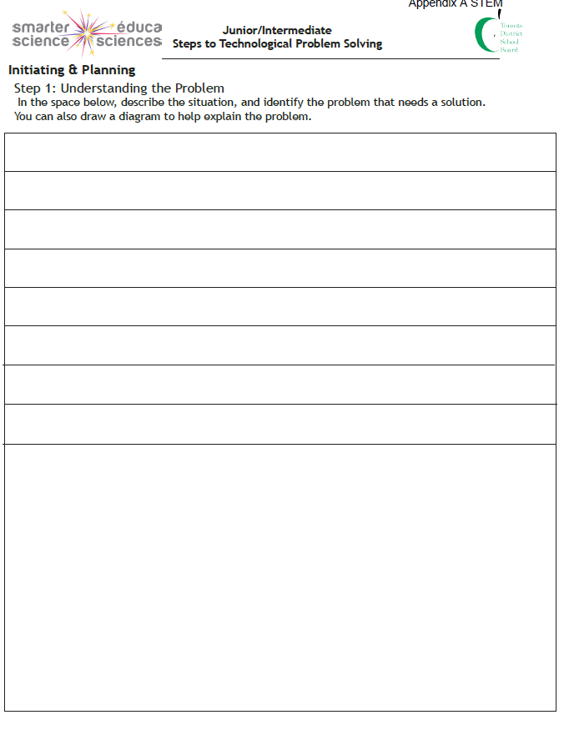

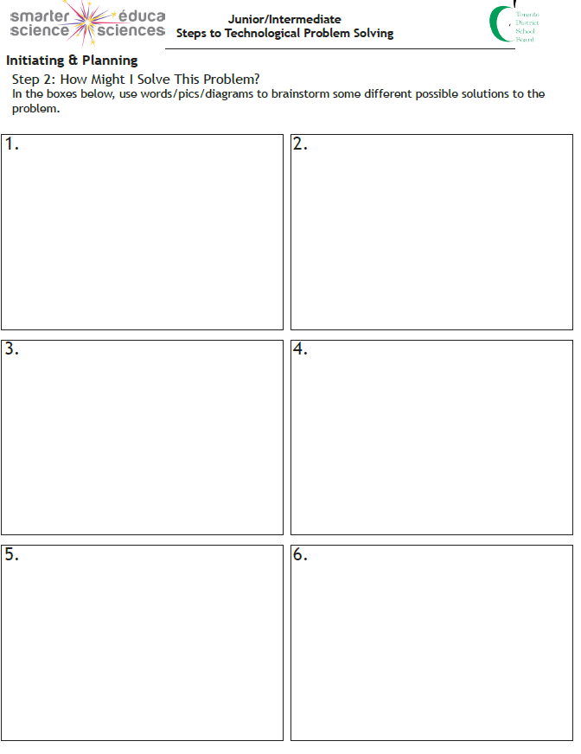

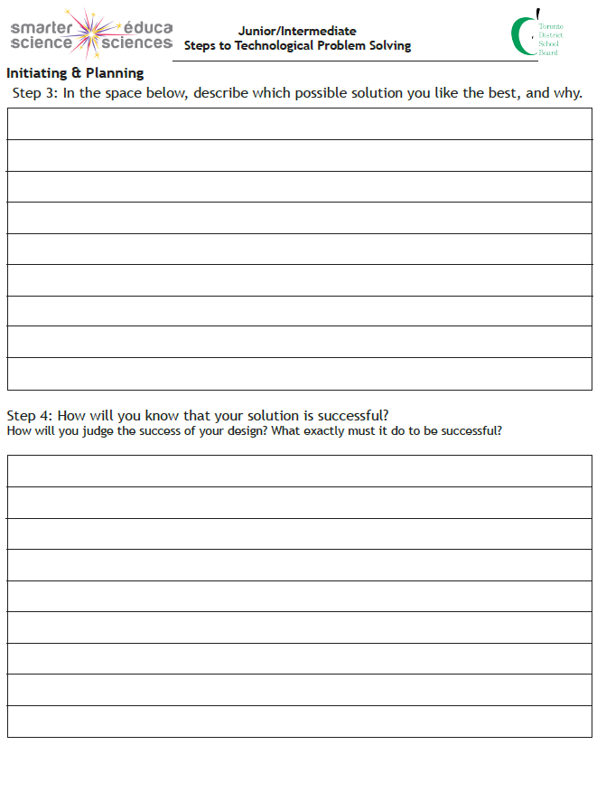

Mathematical Environmental Scan: Geotricity 3.0
Names:
Learning Goal: We are learning to demonstrate an understanding of the geometric properties and relationships of triangles, so that we can redesign an outdoor green space.

Mathematical Connections | Location of Scan and Sketch of Triangular Space
Describe the properties of the triangular space. How is your triangle classified (angles and side length)?

Find the interior angles of the triangle.

Use the Pythagorean relationship to find the hypotenuse.

Success Criteria:

Knowledge and Understanding: I have demonstrated understanding of concepts (triangle properties, interior angles of triangles and the Pythagorean relationship).
Thinking: I used processing skills with considerable effectiveness (collected data, formed conclusions, evaluated the reasonableness of my answers).
Communication: I clearly expressed and communicated my thinking (through a sketch, math vocabulary and numbers).
Application: I effectively transferred my knowledge from math lessons to the outdoor triangular space.

Descriptive Feedback:
Strength:

Next Step:

What is your proposed scale? Justify your answer. ________________________________________________________________________________________________________________________________________________________________________________________________________________________

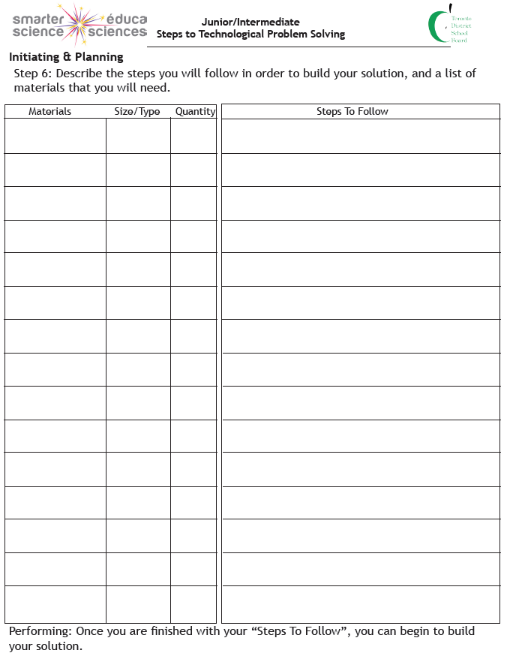
TEACHER APPROVAL: ___________________________________________

GEOTRICITY PLANNING- RUBRIC

CATEGORIES | LEVEL 1 | LEVEL 2 | LEVEL 3 | LEVEL 4
Use of Planning skills – Is your idea well thought out? Have you demonstrated a logical consideration of infrastructure, cost, long term maintenance, sustainability? | Uses planning skills with limited effectiveness | Uses planning skills with some effectiveness | Uses planning skills with considerable effectiveness | Uses planning skills with a high degree of effectiveness
Use of Processing skills – Were you able to decide on a reasonable scale based on the measurements taken? | Uses processing skills with limited effectiveness | Uses processing skills with some effectiveness | Uses processing skills with considerable effectiveness | Uses processing skills with a high degree of effectiveness
Use of Critical/Creative Thinking – Were you able to create a sketch that includes all measurements you will use to build the scale model? Have you included a list of must have building materials in along with your sketch and included how they will be used. | Uses critical/creative thinking processes with limited effectiveness | Uses critical/creative thinking processes with some effectiveness | Uses critical/creative thinking processes with considerable effectiveness | Uses critical/creative thinking processes with a high degree effectiveness
STEP 7: CONSTRUCTION (WED/THURS)
Actually build a model or create a model using technology by
- Using the scale and measurements that you had approved by staff
- Your models will be viewed by staff, students and community judges, so remember that presentation is important – make it something you’ll be proud to show off.
- Keep in mind we are on a tight timeline and use your time effectively!

ANALYZING/INTERPRETING

- Answer questions 1, 2 in the planner

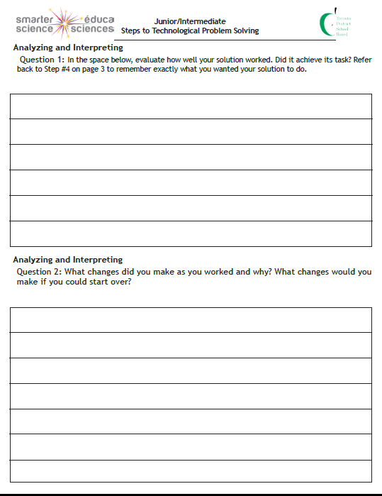

STEP 8: MEDIA PRESENTATION (WED/THURS)

You will need to create a “pitch” for your product.
- Name your product
- Prepare a one-page storyboard of 3 to 5 sections (e.g., by hand or using technology, such as Google Slides or Docs) highlighting the purpose of your design and the advantages of having it in our school community; (i.e., sustainability, cost, suitability for school environment, etc.)
- Your group storyboard cannot have your team members’ names listed/visible

MEDIA PRESENTATION – Rubric – Storyboard
3.4. Students will create a media text of some technical complexity for a specific purpose and audience, using appropriate forms, conventions, and techniques.

CATEGORIES | AREAS OF IMPROVEMENT | LEVEL 3 | NOTEWORTHY OR EXCEPTIONAL AREAS
Knowledge/Understanding of Content – Demonstrated considerable knowledge and understanding of what a storyboard is |  | -Created a considerably good commercial “story”  -Storyboard was organized and focussed including details like framing, camera angles, movement, and sound
Use of Critical and Creative Thinking Processes  Have you demonstrated creativity in the creation of your storyboard? |  | -Storyboard effectively sells your design  -When problems arose, they were dealt with strategically  -The ideas and methods used are imaginative and effective  -There is attention to detail  -The work provokes a lively audience response
Use of Planning Skills– Have you organized your information using appropriate techniques and conventions for an advertisement, with your audience and purpose in mind? |  | -Planned storyboard effectively  -Gathered information, focussed research, and organized material accurately  -Used class time appropriately
Communication – Have you conveyed the intended message in your storyboard? Is your message clear and easy to understand? Does it effectively promote your product? |  | The intended messages in the storyboard clearly communicated the purpose of your design and persuaded the audience to vote for your model
Application of Knowledge and Skills – Have you demonstrated appropriate knowledge and skills for a media text in your storyboard? e.g. techniques used, appropriate form, etc.? |  | Applies knowledge and skills about a media texts/storyboards with considerable effectiveness
COMMENTS:

STEP 9: CULMINATING TASK (Friday)
- On the final afternoon of the project, we will share our projects with everyone here at Robert Service
- Staff/grade 7s will be asked to vote for their favourite ads/designs, so be prepared to be enthusiastic and share your plan/”pitch” in a way that will make people excited to support your project.
GEOTRICITY 3.0 PROJECT SUCCESS CRITERIA

TEAM NAMES:______________________________________________________________________________

CATEGORY | SUCCESS CRITERIA | LEVEL/ COMMENTS
Measurement:  -research, describe, and report measurement  – solve problems that require conversions  involving metric units | -Sketches and scale drawings are provided  -Environmental Scan Organizer completed  -Measuring tools have been used correctly  -All side lengths and angles are measured correctly  -Process for determining side lengths and angles is fully explained, mathematically correct | 4 3 2 1 R  CONSISTENT CONSISTENT SOMEWHAT INCONSISTENT NO  EXEMPLARY EFFECTIVE SOMETIMES INACCURATE EVIDENCE
Number Sense and Numeration:  -solve problems involving proportions, using concrete materials, drawings, and  variables | Scale drawing and calculations  -A reasonable scale has been selected  -Scale calculation steps have been applied correctly  -Scale calculations are correct  -Accurate construction  -Measurements and angles are correct  Final design and scale  -Diagram has been constructed  -Appropriate level of detail included  -Model is constructed precisely and to scale  -All measurements and angles are correct  -Materials have been used appropriately and with care
Geometry and Spatial Sense:  -demonstrate an understanding of the geometric properties of quadrilaterals and circles and applications of geometric properties in the real world | Planning and design  -Designs are appropriate to the space  -Evidence of notes and problem solving; community walk booklet completed
TOTAL
COMMENTS:

A successful project will include:

- Correct measurements (planner, diagram, model)
- Scale
- Well thought out design plan that uses the space in a way that will benefit the community
- Carefully constructed design/diagram with all measurements and angles correct and to scale
- Clear justification of the selected design that fully explains the benefits and possible drawbacks of the chosen project
- Carefully constructed model built with precision and accurate measurements and angles

