Materials for Vertical Garden

Propagation Stage | For Hanging Garden
- propagation sheet (rock wool)  Suggest using an alternative such as coconut fiber that is biodegradable and environmentally friendly. | Materials that are appropriate for your environment where you are hanging your gardens .  - 3M hooks that can be easily used and removed  - Eye hooks can be used if a permanent structure is desired  This will allow gardens to stand securely when attached to the top of the pop bottle ‘tower’.
- propagation tray | 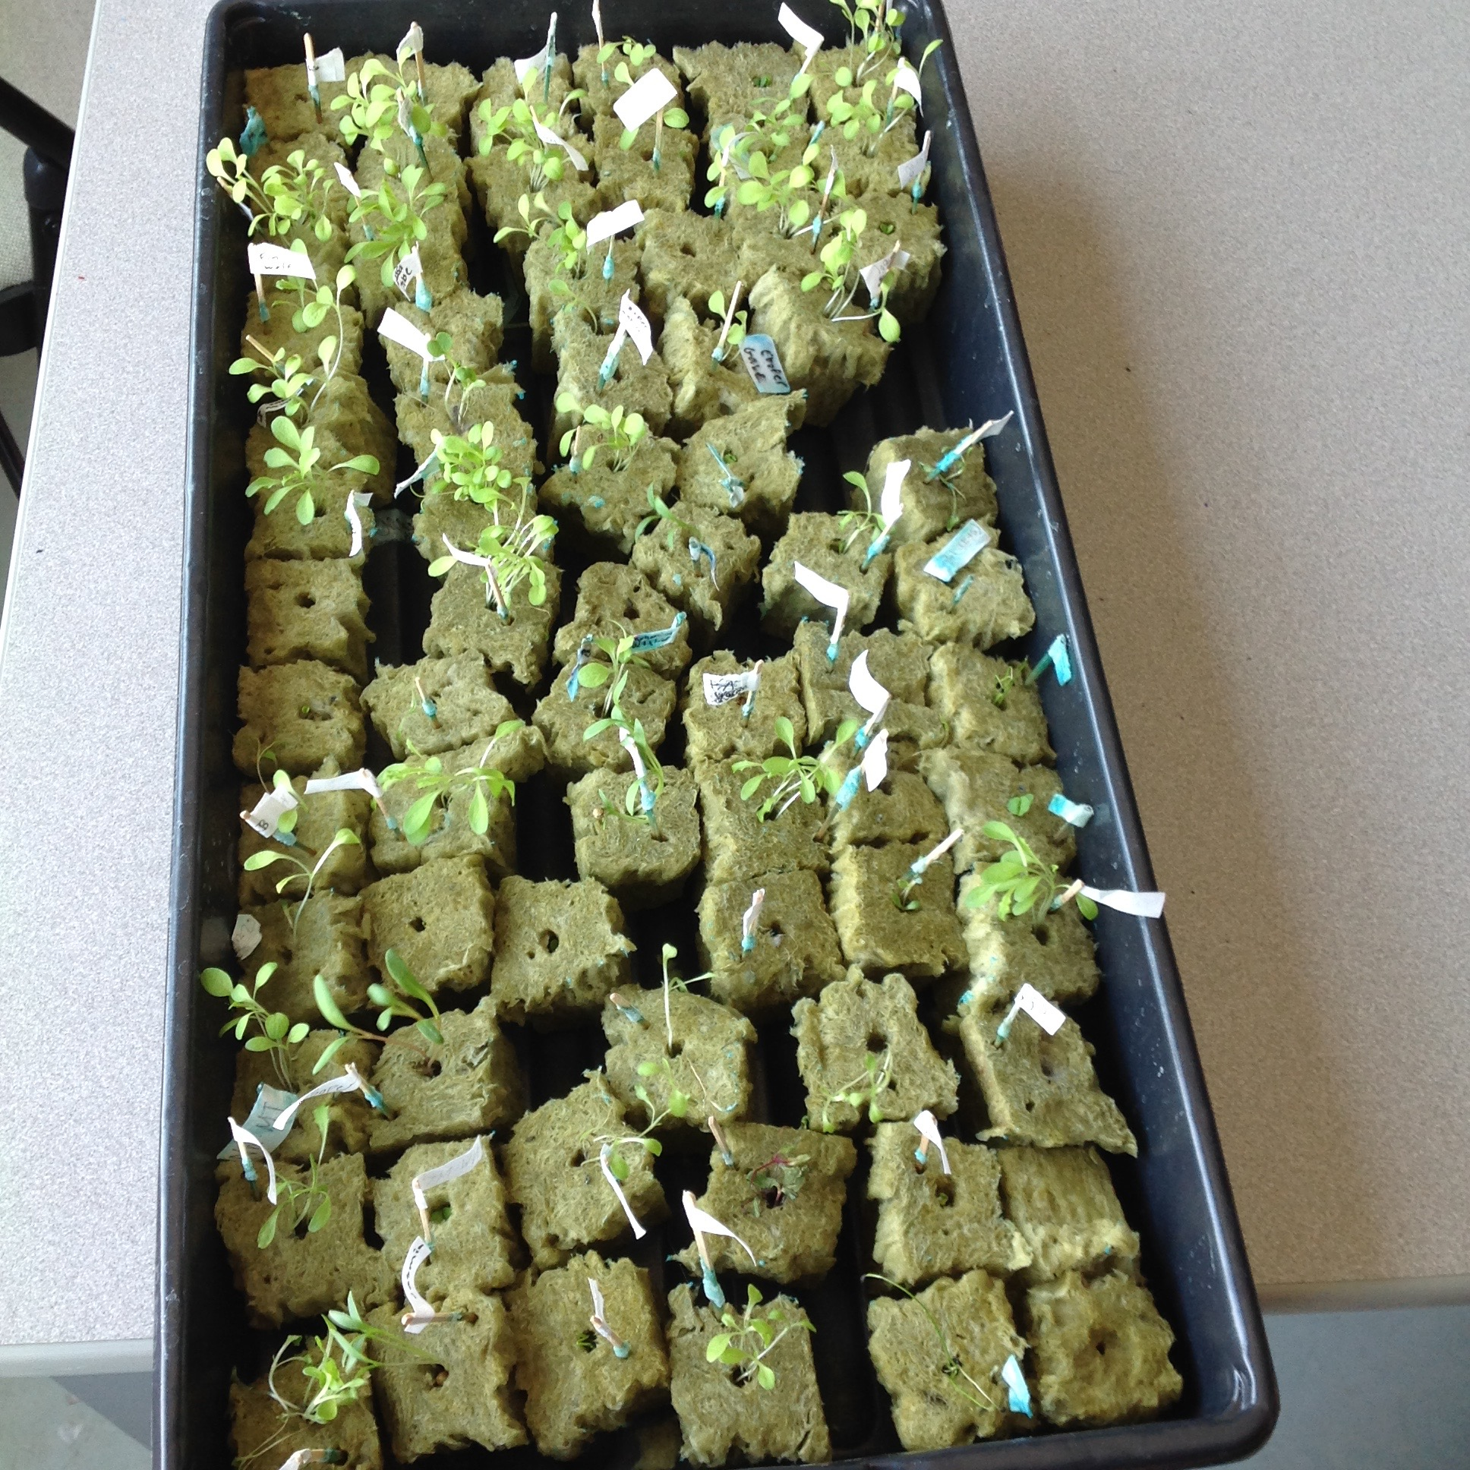
- seeds
  - a variety of types of lettuce seeds
  - various herbs
It is important that the plants chosen are low growing plants to that they fit into the pop bottles.
- Green and Clean Hydroponic Plant Food
(14-5-38)
If you purchase a 1 kg container you will have ample for the entire project for a class of 30.
- pH test liquid
This will be used throughout the growing stage so 2 bottles of 15mL is required.
Structure
- Four, 2L clear pop bottles for each group
- Clay pellets as a growing medium
Could use coconut fiber, soil, perlite, ect...
- 4 x 3cm cube of sponge for each group
- String or wire to secure structure to wooden frame or window frame
This will be modified as needed depending on the space you will create or have for your gardens.
- Tin Foil to wrap the outside of the pop bottles to prevent sunlight exposure to roots and algae growth and to prevent evaporation (approximately two rolls)
Could use white paint or tape to also do the same thing.
- ⅛ inch drill bit OR
- hammer and nail
This is used to create holes in the bottle caps to allow water to flow from one bottle to the next.
Please ensure proper safety precautions and equipment is being used (according to RBSB safety guidelines).

