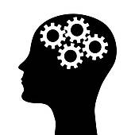
My stressed mind... My calm mind...

Sure I have a full mind...but I’m learning to be mindful.

