Show What You Know Bingo
Thinglink  video tutorial | Google Presentation  Video tutorial pt 1  Video tutorial pt 2 | Adobe Spark  Pick a Video, Page, or Poster  Tutorials
Educreations  video tutorial:  -website version  -App version | Turn in your creations  HERE Create a Google Form for students  Click here  to see projects | 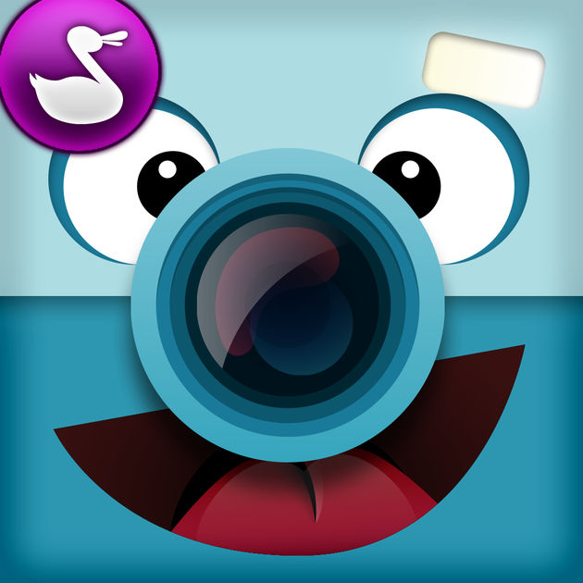  Chatterpix  -App Only
Haiku Deck  video tutorial:  -website version  -App version | iMovie  video tutorial:  Mac desktop version  iPad App version | 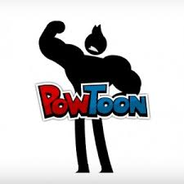  Powtoon  Video tutorial- App
Choose from any of the following to show what you’ve learned. You may pick something that is not on the choice board. Be sure to share when you are finished.
Choice Board used from Lisa Highfil

