The Blanket Exercise
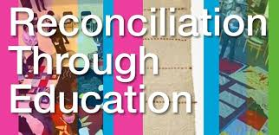
Part One: The Blanket exercise will help you to understand the historical and contemporary relationship between Indigenous and non-Indigenous peoples in Canada. It is important that you actively participate in the activity.

Part Two: After participating in the Blanket Exercise, in one page, reflect on the exercise and your learning. Please include the following:
- description of the role you played in the activity
- how did you feel during the activity
- what was the most important concept you learned about the relationship between Indigenous and non-Indigenous peoples of Canada
- did this exercise help you to better understand the relationship between Indigenous and non-Indigenous peoples of Canada
- what you can do to change/improve the relationship between Indigenous and non-Indigenous peoples of Canada
- benefits of hands-on activities to your understanding of the past

Assessment (Application): Learning Goal: To understand the historical and contemporary relationship between Indigenous and non-Indigenous peoples of Canada.

Success Criteria | Met | Not Met | Descriptive Feedback
I have included details on the activity and the role I played, and how I felt during the exercise.

I have made connections between my experience in the Blanket Exercise and the historical and contemporary relationships between Indigenous and non-Indigenous peoples of Canada.

I have reflected on whether or not this activity has helped me understand the relationship between Indigenous and non-Indigenous peoples of Canada and have included details to support my opinion.

