Vertical Garden Project: Instructions, Tips and Pointers

Clay Pellets - wash before use to get rid of excess dust and soak in water for at least 6 hours
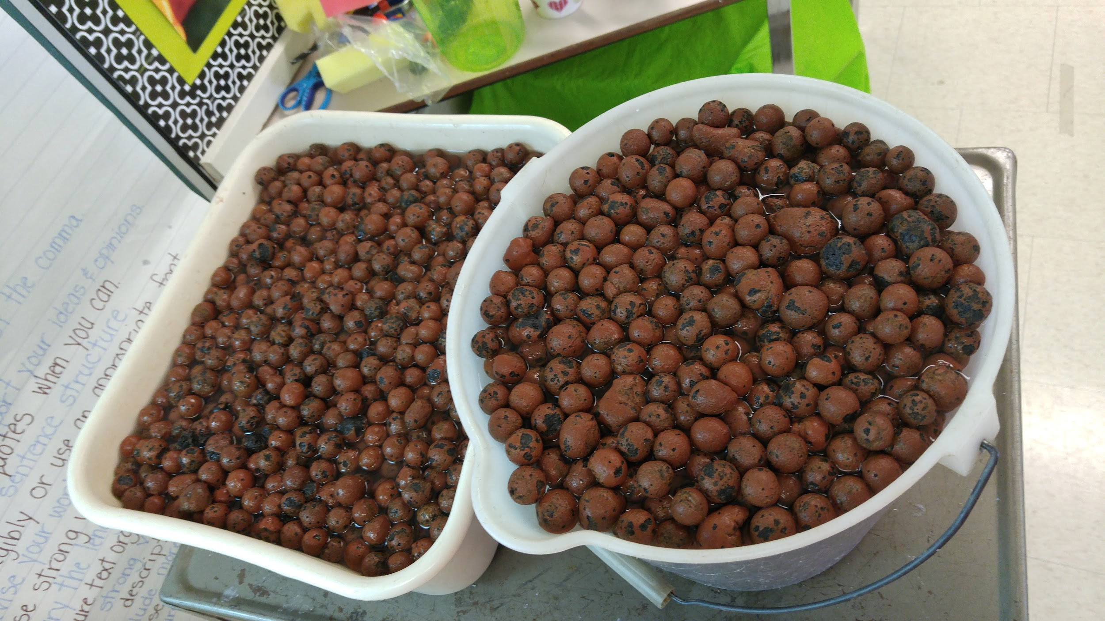
Soaking the clay pellets

Fertilizer - Using the Green & Clean solution, add 1/4 tsp per litre of water. ***WAIT TO FERTILIZE seedlings until they have two weeks of growth, or when the true leaves emerge. Check reservoir daily and adjust fertilizer to maintain optimal pH levels. Once plants are more fully established, check every two to three days.

Sowing Seeds - place two seeds in each peat pellet to increase the odds that one seed will germinate. Remove the smallest seedling and keep the stronger in place. If sowing directly into soil, make sure to plant the BASIL approx 6mm below the surface. LETTUCE seeds need to go a little deeper - about 1 to 1.5 cm.

Switching on the Lights - no need to use any grow lights until after the seeds have germinated.

Growing Seedlings - insufficient light will leave you with weaker and leggy seedlings that are susceptible to damage. A stocky seedling is what you’re aiming for. Place seedlings near a bright, south-facing window to ensure maximum exposure to sunlight. If you have a grow light, suspend them about 2-3 inches above the seedlings. Raise the grow light as the seedlings mature. Note: grow lights using the red spectrum promotes flowering and budding. Blue promotes the absorption of chlorophyll, photosynthesis and growth. For this project, we found that a simple white fluorescent light gave sufficient light!
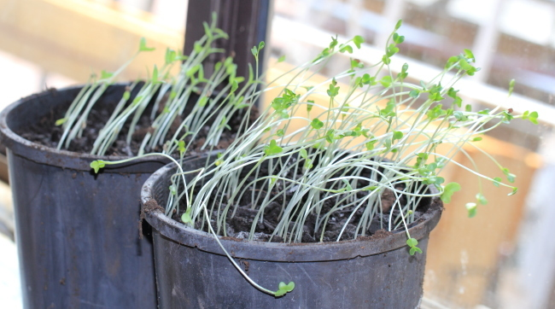

A little too leggy (insufficient light)
Transferring Plants - once the seedling begins to sprout its true leaves (2-3 weeks), you can transfer it to the vertical system. More mature seedlings have stronger stems and leaves, making them less likely to be bruised or damaged by handling or by rough clay pellets.
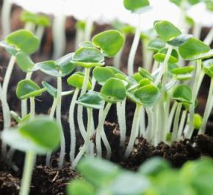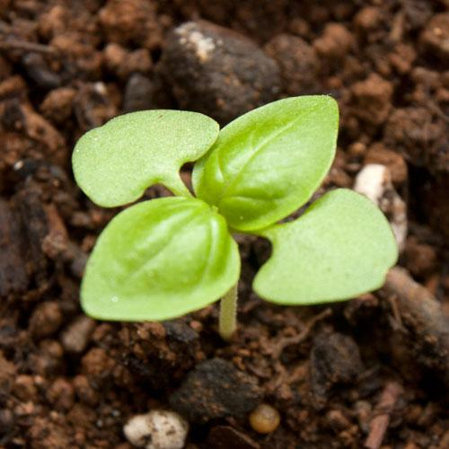
Basil - Seed leaves Basil - True leaves

Testing the water - optimal pH in a hydroponic system is approximately 6.0. When it’s time to cycle the water in the reservoir back into the garden system, begin by checking pH. If necessary, add fertilizer to the water. Check pH again. If the pH is too high, a bit of lemon juice will help to bring it back down.
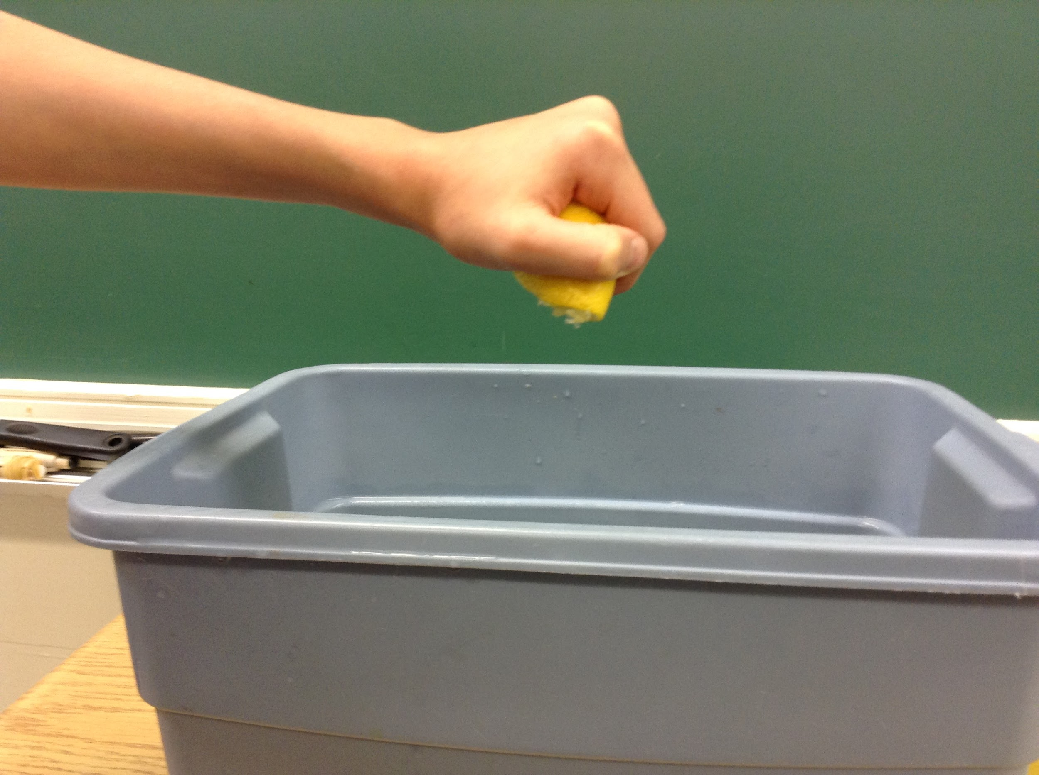
Just a little squeeze

Changing water in the reservoir - water is lost via evaporation and transpiration; this will affect your pH over time. Plants will pull nutrients out of the water; this also has an effect on the overall pH. Change the reservoir water and clean it out once every week to keep nutrient levels in balance and to prevent algae growth.

Wielding the Hole Saw - the more you practice, the better you get with it.
- Drill a pilot hole with a ⅛ to ¼ inch drill bit into the bottom of each 2L bottle.
- Switch to the hole saw. Hold the 2L bottle firmly, place the mandrel against the pilot hole and, using a good deal of pressure on the drill, punch a hole through the bottom of the bottle. ***NOTE: Keep the bottle cap attached while you are drilling. The air pressure inside will prevent the plastic bottle from twisting/collapsing as you drill. Also, tie long hair back and keep loose clothing away from drill!

Photo Credits:
https://rachelmariestone.com/2011/07/30/revolutionary-joy-and-basil/
http://pohnpei-garden.blogspot.ca/2013/04/basil.html
http://www.theseedcollection.com.au/blog/Leggy-Seedlings

