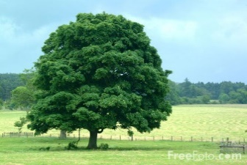
Our class will be participating in Outdoor Classroom Day on May 17, 2018. Outdoor Classroom Day is a day to celebrate outdoor learning and play, and to inspire our students to make outdoor learning and play part of every day. Research has shown that 90% of pupils who go outdoors to learn say that they feel happier and healthier. As well as teaching children critical life skills, schools that introduce more freedom to play and more outdoor learning see less bullying, fewer accidents and greater readiness to learn. (https://outdoorclassroomday.com/ )
We will be taking our learning outside for the day doing activities like shadow art, making nature mandalas, building chipmunk habitats and a nature hike. We will also have a picnic lunch outside together eating our lunches on a picnic blanket. Parents are invited to join us for our walk in Flesherton Hills during the last block of the day. We will start our hike at 1:30. Please send your child with spare clothes, a hat and extra snacks since we will miss breakfast club that morning.
“I took a walk in the woods and came out taller than the trees” Henry David Thoreau

I would like to join my child for this hike: _____________________________________

Our class will be participating in Outdoor Classroom Day on May 17, 2018. Outdoor Classroom Day is a day to celebrate outdoor learning and play, and to inspire our students to make outdoor learning and play part of every day. Research has shown that 90% of pupils who go outdoors to learn say that they feel happier and healthier. As well as teaching children critical life skills, schools that introduce more freedom to play and more outdoor learning see less bullying, fewer accidents and greater readiness to learn. (https://outdoorclassroomday.com/ )
We will be taking our learning outside for the day doing activities like shadow art, making nature mandalas, building chipmunk habitats and a nature hike. We will also have a picnic lunch outside together eating our lunches on a picnic blanket. Parents are invited to join us for our walk in Flesherton Hills during the last block of the day. We will start our hike at 1:30. Please send your child with spare clothes, a hat and extra snacks since we will miss breakfast club that morning.
“I took a walk in the woods and came out taller than the trees” Henry David Thoreau

I would like to join my child for this hike: _____________________________________

