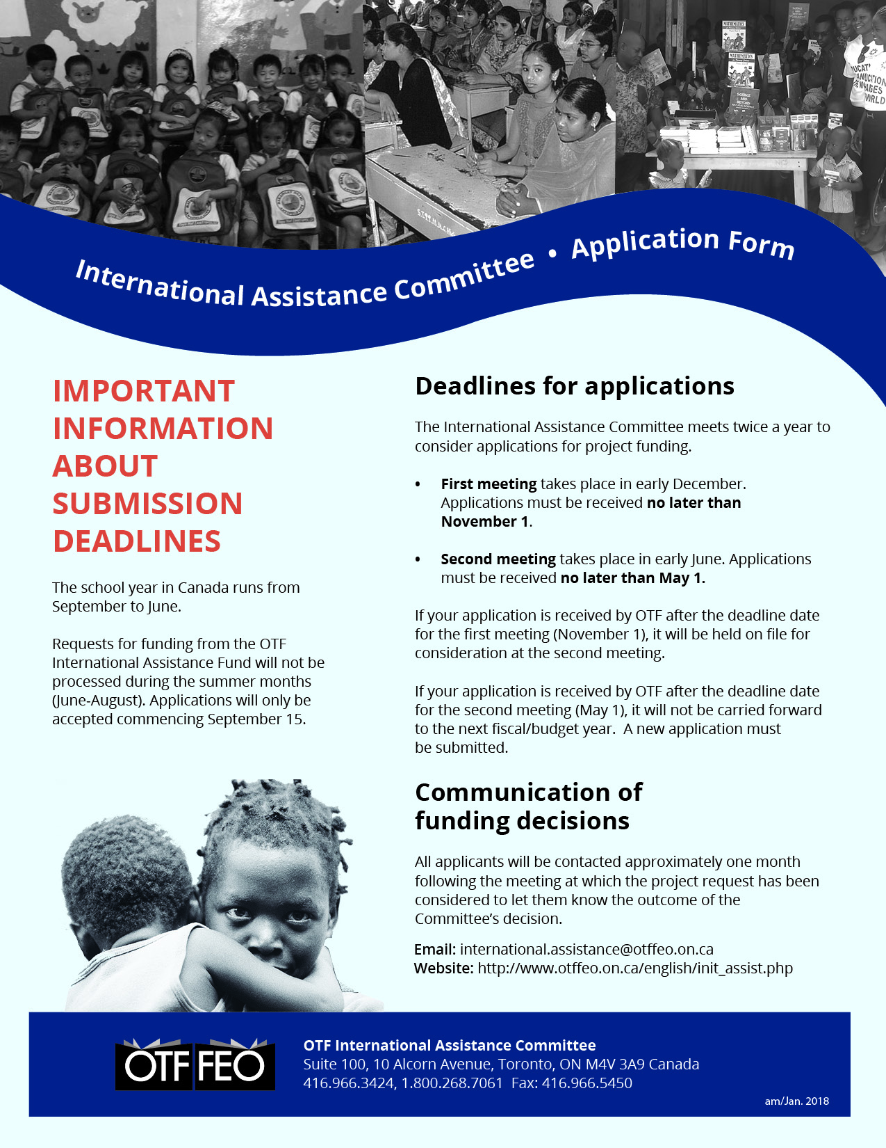

Section 1 - General Information
Name of Contact:
Position:
Organization:
Mailing Address:

Email Address: | Telephone Number (include country code):

Co-ordinator or contact person in developing country, if different from applicant
Name of Contact:
Position:
Organization:
Mailing Address:

Email Address: | Telephone Number (include country code):

Section 2 - Information About Your Application
Project Description Please begin by answering the following questions:
1. Name of the project for which assistance is being requested:
2. How many people (students, teachers, or others) will benefit from your project?
3. Who are these people? What are their ages, gender, and circumstances?
4. How much money are you requesting? Keep in mind that most projects approved by the
OTF International Assistance Committee normally fall within the range of $400 - $500 Canadian.

5. What will you specifically purchase or do with the funds if your request is approved?
6. Briefly describe this project in terms of your perception of the needs.

Section 3 - Application for Funds
Grants approved normally fall within the range of $400 - $500 Canadian
Total cost of project (in Canadian dollars). Please attach a budget breakdown. | $
Amount of grant funds requested in this application: | $

Other Funding
Have you applied, or do you expect to apply to other agencies for funds with reference to this project?

☐ yes ☐ no

If so, please give details of support received.

Name of Agency:

Amount Requested: $
Amount Approved: $
Amount received to date: $

Personal Involvement
Are you prepared to follow this project through? (e.g. assist in purchasing and shipment of materials, correspondence with contact people in developing country, and provide a summary report to OTF)

☐ yes ☐ no

Section 4 – payment information
Please note: Due to the high cost of direct bank transfers (such as SWIFT), OTF prefers to transfer funds via money order or cheque. In exceptional circumstances, we may agree to send funds via direct bank deposit, provided that safe receipt of funds can be guaranteed by you and your banking institution.
Will your bank accept a money order or cheque? ☐ yes ☐ no
Name to be printed on the money order/cheque. Note: Should not be an individual

Please provide a secure mailing address to which funds should be sent:
Please indicate currency | Canadian  $ | U.S.  $ | Other (specify)
Print Name:
Signature:
Date:

Section 5 - Applications from India Only
We are pleased to inform you that the International Assistance Committee will consider a limited number of applications from India in the 2018/19 school year. Please note that only projects received with a completed application form, including full and valid FCRA information, will be considered.
ALL APPLICANTS FROM INDIA MUST PROVIDE
A FOREIGN CONTRIBUTION (REGULATION) ACT (FCRA) REGISTRATION NUMBER
If an FCRA registration number is not included with the application, the request cannot be considered for funding. Any applicant organizations that do not have their own FCRA registration account may be considered for funding if they are able to provide an official letter from a duly registered organization that has agreed to accept grant funds on their behalf. OTF reserves the right to contact such organizations to confirm their credentials.
Name of organization holding FCRA registration number
FCRA registration number
FCRA expiration date
Is this your organization’s FCRA number? |    ☐ yes ☐ no
If this is a sponsor’s number, have you provided the required official letter agreeing to accept funds on your behalf? |    ☐ yes ☐ no

Please note: We are unable to forward grants payable in Indian
rupees because our banker no longer issues money orders payable in Indian currency.

am/October 2018

