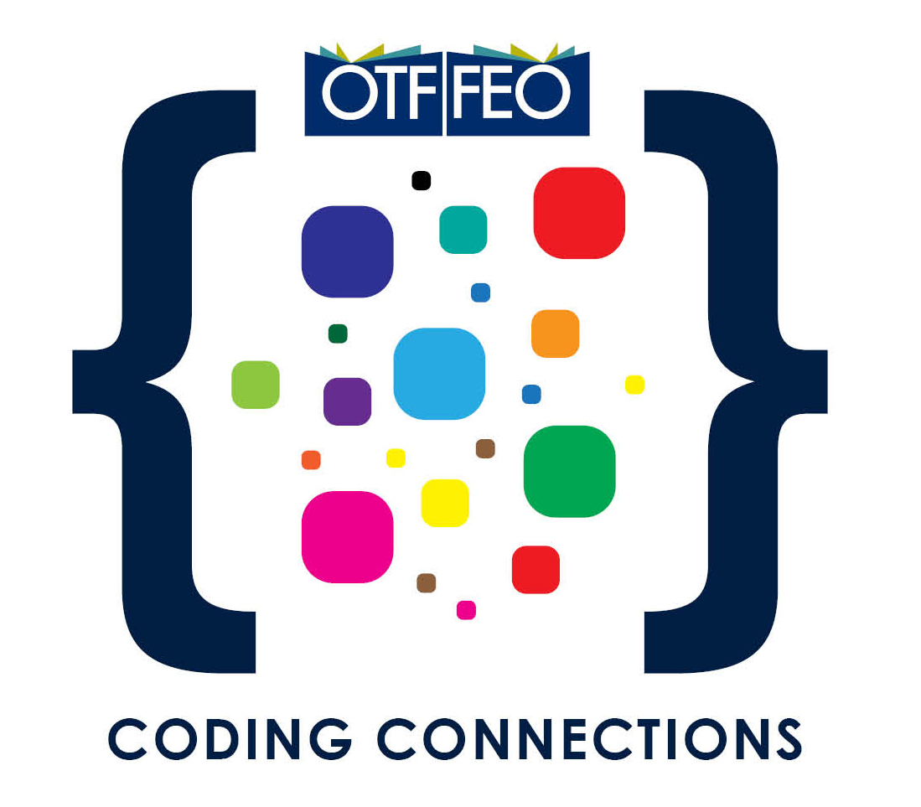
OTF Coding Connections Application Form
Completed application forms must be submitted
by February 14, 2020 @ 5:00 pm.

Please save a copy of the application form on your computer/tablet before you begin working on it. All three sections of this application form must be completed before submission.
Once the form is completed and saved, email a copy of the completed Proposal Application Form as an attachment to coding.connections@otffeo.on.ca.

BEFORE YOU BEGIN
☐ Visit the OTF Coding Connections web page and review our FAQ document to make sure your school and project are a good fit.

☐ Talk with your principal to enlist their support and to learn about any important Board protocols that might apply to your project.

TIPS FOR REVIEWING YOUR APPLICATION FORM

Reviewing the following questions will help you increase your chances of a successful application.
☐ Have I clearly described my own professional learning goals and the learning goals of my team members, e.g. developing coding skills and developing greater knowledge about how students can use coding in a specific discipline, etc.?
☐ Have I provided a good description of my school and the students who will be part of our learning journey?
☐ Have I thought through and listed a variety of different ways that we can share what we learn through our project with others at our school and elsewhere?
☐ Have I listed resources that will support our learning and our sharing activities?
☐ Do my preliminary budget amounts align with the ideas and purchases in our proposal and are my totals and subtotals accurate?
☐ Have all team members agreed to the program requirements/agreements in Section 5?

Note: Fields will expand as information is entered.

SECTION 1: APPLICANTS’ INFORMATION

Team Leader – Participant 1 (Contact Person)
Name
School Board
School Name/Department
City/Province/Postal Code
School Phone | Home Phone |  |  | School FAX
Work Email |  | Personal Email

Affiliate Membership
☐ AEFO ☐ ETFO ☐ OECTA ☐ OSSTF
Total Years of Teaching Experience
Current Teaching Assignment

Participant 2
Name
School Board
School Name/Department
City/Province/Postal Code
School Phone | Home Phone |  |  | School FAX
Work Email |  | Personal Email

Affiliate Membership
☐ AEFO ☐ ETFO ☐ OECTA ☐ OSSTF
Total Years of Teaching Experience
Current Teaching Assignment

Participant 3
Name
School Board
School Name/Department
City/Province/Postal Code
School Phone | Home Phone |  |  | School FAX
Work Email |  | Personal Email

Affiliate Membership
☐ AEFO ☐ ETFO ☐ OECTA ☐ OSSTF
Total Years of Teaching Experience
Current Teaching Assignment

Participant 4
Name
School Board
School Name/Department
City/Province/Postal Code
School Phone | Home Phone |  |  | School FAX
Work Email |  | Personal Email

Affiliate Membership
☐ AEFO ☐ ETFO ☐ OECTA ☐ OSSTF
Total Years of Teaching Experience
Current Teaching Assignment

Note: Fields will expand as information is entered.
SECTION 2: ABOUT YOUR SCHOOL AND CLASS
Tell us a little about your school. (Max: 150 words)
Where is the school located? How many students attend? What grades are included (K – 8; 9 – 12; etc.)?

Tell us about your class(es). (Max: 200 words)
Who are the students in your class(es) that you hope will be part of your OTF Coding Connections project?

Tell us anything about your school or class(es) that makes them unique. (Max: 200 words)
Is there anything specific about your school or the students you teach that you think would make your setting a particularly good environment for introducing experiences in coding?

Note: Fields will expand as information is entered.
SECTION 3: PROJECT IDEAS (PLEASE USE POINT FORM)
Project Title
What content area(s) do you hope your project will focus on? (Max: 150 words)
What are the two or three areas of inquiry that you hope your project will include?

Identify the professional learning goals you plan to achieve through your project. (Max: 150 words)
OTF Coding Connections is a unique opportunity for teachers to pursue their own personal and professional learning goals. Lynx and/or coding may be new to you, so your professional learning goals could be ‘big picture’ or specific. What are you wanting to explore, discover, or deepen about how coding and computational thinking might empower your learners? What specific learning goals do you and your team hope to develop through this project (e.g. developing coding skills, greater knowledge about cross-curricular integration, how students can use coding in a specific discipline, metacognition, deeper learning, global competencies, etc.)?
The main goals for our team of teachers are to learn …

Assessment: How will you determine that your team’s learning goals have been met? (Max: 150 words)
We will be able to test whether our own learning goals have been met by …

How do you plan to share your team’s learning with others? (Max: 150 words)
Sharing what your team learns will be an important part of your OTF Coding Connections journey. Think about some possible ways you will share what you learn with others in your school or beyond.

To share what we have learned with others, we will …
☐ Meet with other teachers in our school or board
☐ Blog
☐ Facilitate workshops
☐ Present at conferences
☐ Write an article for a professional journal
☐ Host a webinar or podcast
☐ Use social media
☐ Share on TeachOntario
☐ Other (please specify)

List some resources you plan to use for your project. (This can be an ongoing list)
Here are some resources we will use to support our learning and the learning experiences of our students:

Note: Fields will expand as information is entered.
SECTION 4: PRELIMINARY BUDGET (MUST BE COMPLETED AS PART OF THE APPLICATION AND MUST
NOT EXCEED $5,000 or include hardware purchases)
Note: It is understood that changes to your budget may be made once you have completed the training session
in April and have refined your project.
Project Title
Project Leader
Email
BUDGET PROPOSAL (MUST NOT EXCEED $5,000 OR INCLUDE HARDWARE PURCHASES)
Expense Descriptions | Particulars:  (timeline, location, etc.) | Project Budget
Release Time |  | $
Resources |  | $
Materials |  | $
Other (Describe)  Click here to enter text. | Click here to enter text. | Click here to enter text.
Total Proposed Expenses |  | $

SECTION 5: PROGRAM REQUIRMENTS AND PARTICIPANT AGREEMENTS
By submitting this application form, I/we agree to the following required program components:
☐ Team leader will attend the 2-day training session on April 3-4, 2020.
☐ Team members will participate in three online professional learning opportunities (two in 2020 and one in 2021).
☐ Team leader will submit an Interim Report by November 30, 2020.
☐ Team leader will submit a Final Report by March 15,2021.
☐ Team members will participate in a culminating event to celebrate and share their learning in the spring of 2021.
☐ Team leader will keep track of all expenses and provide receipts for all expenditures.

