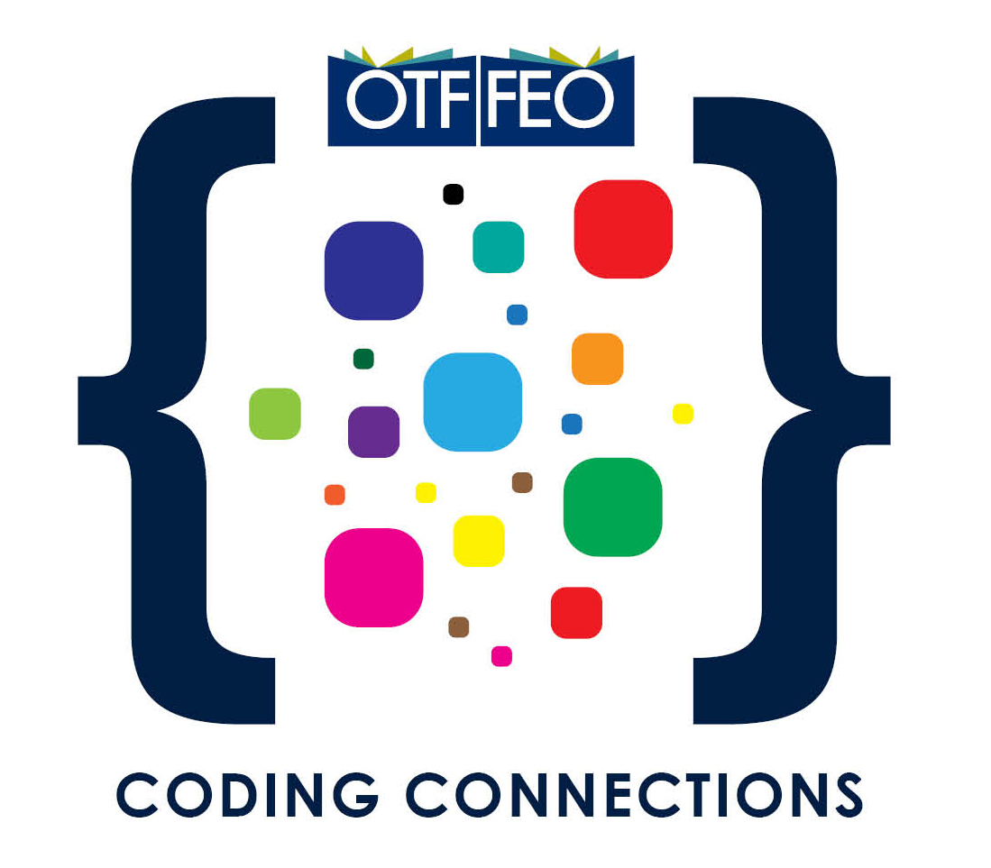
OTF Coding Connections Application Form
Completed application forms must be submitted
by February 14, 2020 @ 5:00 pm.

Please save a copy of the application form on your computer/tablet before you begin working on it. All three sections of this application form must be completed before submission.
Once the form is completed and saved, email a copy of the completed Proposal Application Form as an attachment to coding.connections@otffeo.on.ca.

BEFORE YOU BEGIN
☐ Visit the OTF Coding Connections web page and review our FAQ document to make sure your school and project are a good fit.

☐ Talk with your principal to enlist their support and to learn about any important Board protocols that might apply to your project.

TIPS FOR REVIEWING YOUR APPLICATION FORM

Reviewing the following questions will help you increase your chances of a successful application.
☐ Have I clearly described my own professional learning goals and the learning goals of my team members, e.g. developing coding skills and developing greater knowledge about how students can use coding in a specific discipline, etc.?
☐ Have I provided a strong rationale for the activities we will carry out to support our learning journey?
☐ Have I thought through and listed a variety of different ways that we can share what we learn through our project with others at our school and elsewhere?
☐ Have I listed resources that will support our learning and our sharing activities?
☐ Do my budget amounts align with the activities and purchases in our proposal and are my totals and subtotals accurate?
☐ Have all team members agreed to the program requirements/agreements in Section 4?

Note: Fields will expand as information is entered.

SECTION 1: APPLICANTS’ INFORMATION

Team Leader – Participant 1 (Contact Person)
Name
School Board
School Name/Department
City/Province/Postal Code
School Phone | Home Phone |  |  | School FAX
Work Email |  | Personal Email

Affiliate Membership
☐ AEFO ☐ ETFO ☐ OECTA ☐ OSSTF
Total Years of Teaching Experience
Current Teaching Assignment

Participant 2
Name
School Board
School Name/Department
City/Province/Postal Code
School Phone | Home Phone |  |  | School FAX
Work Email |  | Personal Email

Affiliate Membership
☐ AEFO ☐ ETFO ☐ OECTA ☐ OSSTF
Total Years of Teaching Experience
Current Teaching Assignment

Participant 3
Name
School Board
School Name/Department
City/Province/Postal Code
School Phone | Home Phone |  |  | School FAX
Work Email |  | Personal Email

Affiliate Membership
☐ AEFO ☐ ETFO ☐ OECTA ☐ OSSTF
Total Years of Teaching Experience
Current Teaching Assignment

Participant 4
Name
School Board
School Name/Department
City/Province/Postal Code
School Phone | Home Phone |  |  | School FAX
Work Email |  | Personal Email

Affiliate Membership
☐ AEFO ☐ ETFO ☐ OECTA ☐ OSSTF
Total Years of Teaching Experience
Current Teaching Assignment

Note: Fields will expand as information is entered.
SECTION 2: PROJECT PROPOSAL (PLEASE USE POINT FORM)
Project Title
Please provide a description of your project proposal. (Max: 200 words)
What are the three or four “big ideas” that your project will encompass?

Identify the professional learning goals you plan to achieve through your project. (Max: 150 words)
OTF Coding Connections is intended as a unique opportunity for teachers to pursue their own personal and professional learning goals. What specific learning goals do you and your team hope to develop through this project?
Our goals are to learn …

Assessment: How will you determine that your team’s learning goals have been met? (Max: 150 words)
We will be able to test whether our own learning goals have been met by …
How do you plan to share your team’s learning with others? (Max: 150 words)
Sharing your learning goals should take a number of forms, e.g. working with other teachers in their classroom, blogging, facilitating workshops, presenting at conferences, social media, etc.

To share what we have learned with others, we will …

Describe how your project will contribute to enhancing student learning and development. (Max: 150 words)
What will your students learn through this project? How will their experiences of coding be enhanced?

Our students will …

List some activities that you might conduct to help meet the goals of both you and your students?
(Max: 150 words)

The main activities we will undertake are …

List resources you plan to use for your project. (This can be an ongoing list.)
Here are some resources we will use to support our learning and the learning experiences of our students:

Note: Fields will expand as information is entered.
SECTION 3: PROJECT BUDGET PROPOSAL MUST BE COMPLETED AS PART OF THE APPLICATION AND MUST NOT
EXCEED $5,000 or include hardware purchases
Project Title
Project Leader
Email

BUDGET PROPOSAL (MUST NOT EXCEED $5,000 OR INCLUDE HARDWARE PURCHASES)
Expense Descriptions | Particulars:  (timeline, location, etc.) | Project Budget
Release Time |  | $
Resources |  | $
Materials |  | $
Other (Describe)  Click here to enter text. | Click here to enter text. | Click here to enter text.
Total Proposed Expenses |  | $

SECTION 4: PROGRAM REQUIREMENTS AND PARTICIPANT AGREEMENTS
By submitting this application form, I/we agree to the following required program components:
☐ Team leader will attend the 2-day training session on April 3-4, 2020.
☐ Team members will participate in three online professional learning opportunities (two in 2020 and one in 2021).
☐ Team leader will submit an Interim Report by November 30, 2020.
☐ Team leader will submit a Final Report by March 15,2021.
☐ Team members will participate in a culminating event to celebrate and share their learning in the spring of 2021.
☐ Team leader will keep track of all expenses and provide receipts for all expenditures.

