Individual Participant Reflection
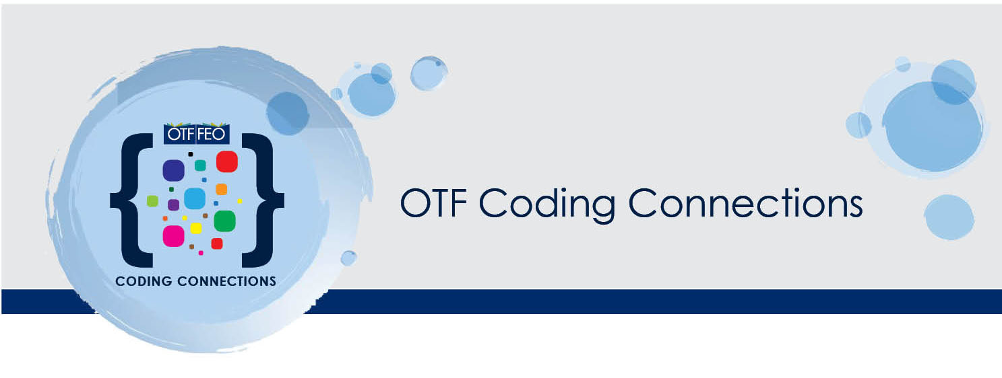

Project Title:
Team Leader:
Teacher Participant:

- What was/were the professional learning goal(s) of the project?

- Please describe your professional learning journey through this project. Did you achieve the professional learning goal(s) you hoped you would? How do you measure this?

- Describe any challenges you faced completing this project.

- Could others benefit from this project? How could the project learnings be shared?

- Please provide any suggestions you have for how we might improve the OTF Coding Connections project in future.

