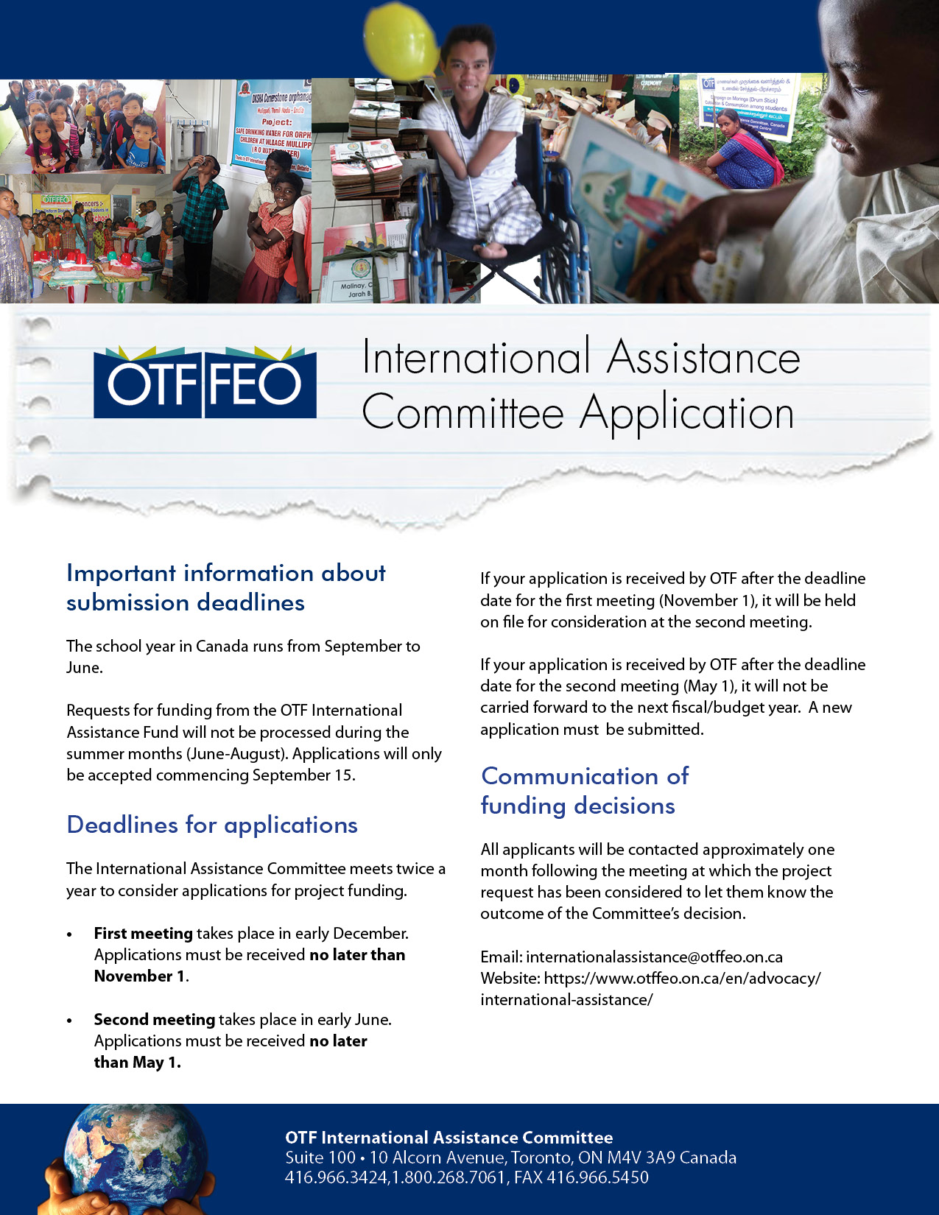
Section 1 - General Information
Name of Contact:
Position:
Organization:
Mailing Address:

Email Address:
Telephone Number (include country code): | Mobile Number (including country code):

Co-ordinator or contact person in developing country, if different from applicant
Name of Contact:
Position:
Organization:
Mailing Address:

Email Address:
Telephone Number (include country code): | Mobile Number (include country code):

 | Section 2 - Information About Your Application
 | Project Description Please begin by answering the following questions:
 | - Name of the project for which assistance is being requested:
 | - How many people (students, teachers, or others) will benefit from your project?
 | - Who are these people? What are their ages, gender, and circumstances?
 | - How much money are you requesting? Keep in mind that most projects approved by the OTF International Assistance Committee normally fall within the range of $400 - $500 Canadian.
- What will you specifically purchase or do with the funds if your request is approved?
(Provide estimated budget)
 | - Briefly describe this project in terms of your perception of the needs.
Section 3 - Application for Funds
Grants approved normally fall within the range of $400 - $500 Canadian
Total cost of project (in Canadian dollars). |  | $
Amount of grant funds requested in this application: |  | $

Other Funding
Have you applied, or do you expect to apply to other agencies for funds with reference to this project?

Yes No

If so, please give details of support received.

Name of Agency:
Amount Requested: $
Amount Approved: $
Amount received to date: $

Personal Involvement
Are you prepared to follow this project through? (e.g., assist in purchasing and shipment of materials, correspondence with contact people in developing country, and provide a summary report to OTF)

Yes No

Section 4 – payment information
Please note: Due to the high cost of direct bank transfers (such as SWIFT), OTF prefers to transfer funds via alternative methods. In exceptional circumstances, we may agree to send funds via direct bank transfer, provided that safe receipt of funds can be guaranteed by you and your banking institution.
Are you able to receive funds by:

- EFT (Electronic Funds Transfer – within Canada ONLY)
- World Remit
- Western Union
- Bank Wire Transfer (e.g., SWIFT)

If you are able to receive funds by WorldRemit or Western Union, please provide the following:

Full legal name as shown on legal documentation, including:

First Name:
Middle Name (if applicable):
Last Name:
Mobile phone number:
Email address:

Please indicate currency you are able to receive funds in: | - Canadian | - U.S. | - Other: Specify ________________
Print Name:
Signature:
Date:

Section 5 - Applications from India Only
Please note that only projects received with a completed application form will be considered. To comply with the Government of India Foreign Contribution (Regulation) Act (FCRA) and OTF’s funding requirements, your application MUST include the following documents:
Current FCRA document
Current annual report
Current audit report
NGO Darpan unique ID
Change Detail Certificate
FCRA Bank Details (Section 6)
ALL APPLICANTS FROM INDIA MUST PROVIDE
A FOREIGN CONTRIBUTION (REGULATION) ACT (FCRA) REGISTRATION NUMBER
If a valid FCRA registration number, current annual report, recent audit report and NGO Darpan unique ID are not included with the application, the request cannot be considered for funding. Also, if you do not have a valid FCRA Bank Account, we are unable to send funds and your request cannot be considered for funding.
Name of organization holding FCRA registration number:
FCRA registration number:
FCRA expiration date:
Date of Annual Report:
Date of Audit Report:
NGO Darpan Unique ID:
I hereby certify that this organization has a Government approved bank account that is able to receive funds from Canada and that the details provided on the following section (i.e., Section 6) are accurate. | Print Name:  Signature:  Date:

Section 6 - Applications from India Only
Please provide ALL of the following information which will be required if your project is approved:
Name of Bank: | State Bank of India  New Delhi Main Branch
Address of the Branch: | FCRA Cell, 1st Floor, 11, SansadMarg  New Delhi – 110 001 - INDIA
e-mail address of the Bank: | fcra.00691@sbi.co.in
Phone number of the Bank: | +91 1123374392, +91 1123374143
SWIFT Code: | SBININBB104
Beneficiary Bank Account Name:
NOTE: The account holder must be an institution/NGO. Please provide the exact name used on the account. The omission of a single word/letter may lead to problems with the transfer.

Account Type: | FCRA Savings Bank Account  FCRA Current Bank Account  Other:
Beneficiary Bank Account Number:
Beneficiary Address:
Beneficiary mobile number:
Beneficiary e-Mail Address:
Name and position of all who have signing and banking authority for this account:

PAN No (Permanent Account Number):
FCRA Number:

am/June 2021

