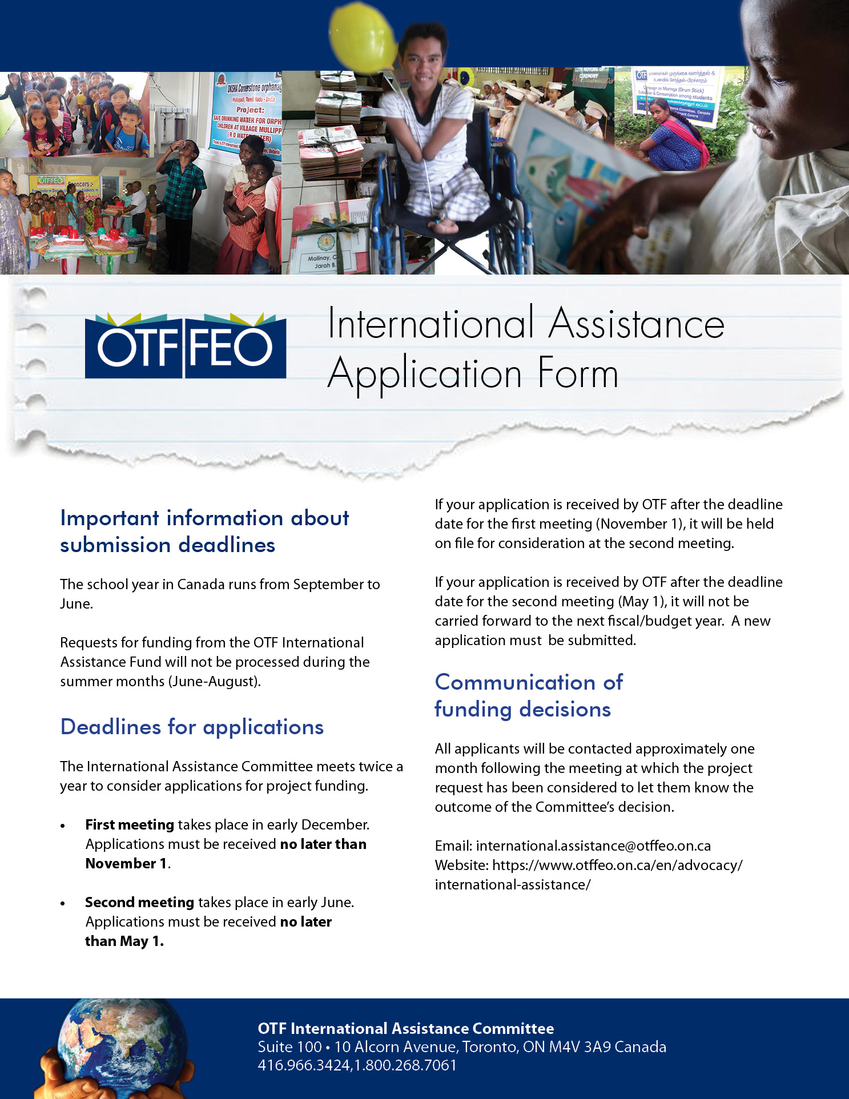
Section 1 - General Information
Name of contact:
Position:
Organization:
Street Number and Name:
(PO BOX NOT ACCEPTED)
City: |  | Postal Code:
Country:
Email address:
Telephone number (including country code): | Mobile number (including country code):

Co-ordinator or contact person in developing country, if different from applicant
Name of contact:
Position:
Organization:
Street Number and Name:
(PO BOX NOT ACCEPTED)
City: |  | Postal Code:
Country:
Email address:
Telephone number (including country code): | Mobile number (including country code):

 | Section 2 - Information About Your Application
 | Project Description Please begin by answering the following questions.
 | - Name of the project for which assistance is being requested:
 | - How many people (students, teachers, or others) will benefit from your project?
 | - Who are these people? What are their ages, gender, and circumstances?
 | - How much money are you requesting? Keep in mind that most projects approved by the OTF International Assistance Committee normally fall within the range of $400 - $500 Canadian.
- What will you specifically purchase or do with the funds if your request is approved?
(Provide detailed estimated budget)
 | - Briefly describe this project in terms of your perception of the needs.
Section 3 - Application for Funds
Grants approved normally fall within the range of $400 - $500 Canadian
Total cost of project (in Canadian dollars). |  | $
Amount of grant funds requested in this application: |  | $

Other Funding
Have you applied, or do you expect to apply to other agencies for funds with reference to this project?

Yes No

If yes, please give details of support received.

Name of Agency:
Amount Requested: $
Amount Approved: $
Amount received to date: $

Personal Involvement
Are you prepared to follow this project through? (e.g., assist in purchasing and shipping materials, correspondence with contact people in developing country, and providing a summary report to OTF)

Yes No

Section 4 – payment information (Applicants from India, please skip to Section 5)
- EFT (Electronic Funds Transfer – within Canada ONLY)
- Bank Wire Transfer (e.g., SWIFT)

For all international payments, please provide the following banking information
Name of bank:

Branch name:
Branch address:
SWIFT code:
Bank account name:
Bank account number:
Beneficiary’s mailing address
Street Number and Name:
City:
Country: |  | Postal Code:
Beneficiary’s email address:
Beneficiary’s mobile phone number:
Please indicate currency you  are able to receive funds in: | Canadian |  | U.S.

Section 5 - Applications from India Only
Please note that only projects received with a completed application form will be considered. To comply with the Government of India Foreign Contribution (Regulation) Act (FCRA) and OTF’s funding requirements, your application MUST include ALL of the following documents:
Current FCRA document, renewal document(s), any extension letters
Current annual report
Current audit report
NGO Darpan unique ID
SBI FCRA Bank Details letter
ALL APPLICANTS FROM INDIA MUST PROVIDE
A FOREIGN CONTRIBUTION (REGULATION) ACT (FCRA) REGISTRATION NUMBER
If a valid FCRA registration number, current annual report, current audit report and NGO Darpan unique ID are not included with the application, the request cannot be considered for funding. Also, if you do not have a valid FCRA Bank Account, we are unable to send funds and your request cannot be considered for funding.
Name of organization holding FCRA registration number:
FCRA registration number:
FCRA expiration date:
Date of annual report:
Date of audit report:
NGO Darpan Unique ID:
I hereby certify that this organization has a Government approved bank account that is able to receive funds from Canada and that the following banking details are accurate. | Print Name:  Date:

Section 6 - Applications from India Only
Name of Bank: State Bank of India, New Delhi Main Branch
Address of the branch: FCRA Cell, 1st Floor, 11, SansadMarg, New Delhi – 110 001 - INDIA
E-mail address: fcra.00691@sbi.co.in |  |  | Phone number: +91 1123374392, +91 1123374143
SWIFT code: SBININBB104
Please provide ALL of the following information which will be required if your project is approved:
Beneficiary bank account name:
(NOTE: The account holder must be an institution/NGO. Please provide the exact name used on the account. The difference of a single word/letter may cause problems with the transfer.)

Account type: | FCRA Savings Bank Account  FCRA Current Bank Account  Other:
Beneficiary bank account number:
Please indicate currency you are able to receive funds in: |  |  |  | Canadian U.S.
Beneficiary’s mailing address
Street Number and Name:
City: |  |  |  | Postal Code:
Beneficiary mobile number:
Beneficiary e-mail address:
Name and position of all who have signing and banking authority for this account:

PAN No (Permanent Account Number):
FCRA number:

am/March 2024

