*****GRADE 9 / 10 COMPOSITION USING GARAGEBAND***

**Learning Goals**

A2.3 Apply the elements of music and related concepts appropriately when composing and/or arranging simple pieces of music

A3.3 use current technology when practising, performing, composing, and/or arranging music

**Success Criteria**

I can use the creative process to compose a song.

I can use the technology of GarageBand for iPad to sequence and record components of my song.

**Task**

Your assignment is to compose an original song using GarageBand for iPad. Your song should be at least **32 bars** long, and it should have at least **4 track layers**. You will use the creative process to work through steps in creating your song as you explore the basic functions of the GarageBand app.

***STEP 1* (Challenging/Inspiring; Imagining/Generating)**

To start, decide on how the song will be inspired and created. First of all, will your song have **lyrics** or will it be **instrumental**? What **form** will it take (e.g., intro/verses/choruses/bridge; AABA song form, film score, jingle)? What **mood** or **musical style** will your song have? If you decide to add lyrics, get song theme ideas from the following link: http://www.lyricideas.com/index_files/SongThemeIdeas.html

***STEP 2* (Planning/Focusing)**

Open **GarageBand** on the iPad. Click the **+ sign** at the top left corner and tap to create a new song. It will be titled “My Song,” which you can rename later. (*Tip:* If you want to know the functions of each icon, tap the **? sign** at the top right corner.)

**Instruments**

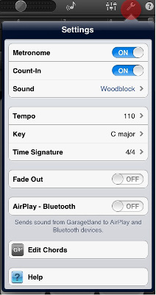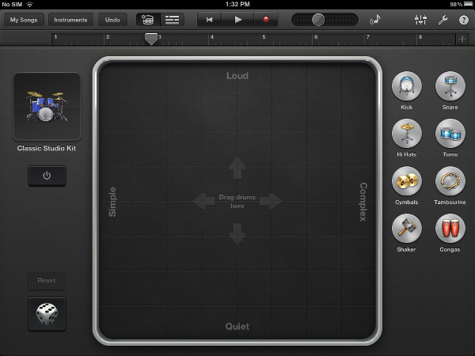Various **instruments** will appear and you can scroll through the list to choose one as your first recording instrument. A good starting point is the **Smart Drums**. Click the **Settings button** (wrench icon, top right). Here you can set up parameters for your song (e.g., count-in, metronome sound, tempo, key, time signature, fade-out, etc.). You can set the speed of your song in the **Tempo** window by **tapping a beat** at your desired speed, or increasing/decreasing the **BPM number** (beats per minute). When you are done, tap outside the Settings window to close it.

**Song Sections**

Making sections of your song will help you to copy-paste or move around certain sections **such as intro, verses, choruses, bridge, and outro**. Each of these sections are **named with letters,** and by default a song contains **8-bar repeating sections**. **Add** at least *three* more 8-bar sections or **adjust length** of sections already created by tapping on the **+ sign** at the right edge of the numbered ruler.

***STEP 3* (Exploring/Experimenting; Producing Preliminary Work)**

**Drums**

In **Smart Drums**, choose a **drum sound** (electronic or acoustic options) on the right side. Drag separate drum components (e.g., kick, snare, hi hats, toms) into the **grid** to create a groove. Explore different grooves by dragging left or right (**simple/complex**) and volume by dragging up and down (**loud/quiet**). You may also explore the **automatic groove** tool (die on bottom left). Play test the grooves by tapping the **power button** (middle left, circle/line) on and off. Choose all sections or just one section you wish to record the drum groove, and tap the **record button** (red circle at the top). You may turn the **metronome** (triangular shape, top right side) on or off. A more complex method involves recording each drum part separately and then layering it with more parts.

If you wish to **edit** the track, tap the **Track View** button (top near the middle), and double-tap to see editing options (e.g., cut, copy, delete, loop, split). Tap the **Undo button** (curving arrow, top left) if you wish to undo previous edits.

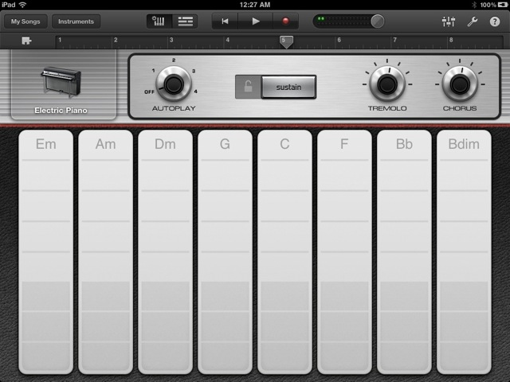**Chords**

Tap **Instruments** (top left) and choose **Smart Keyboard**. Choose a keyboard type (pianos, organs, synthesizers). You can adjust the sounds by turning the two **effects knobs**.

The default **key** is C major, but you may change the key in **Settings** (wrench). A number of common major and minor **chords** are displayed and corresponding with your chosen key. Test them out by tapping and holding the vertical strips. **Bass** notes are on the lower parts of the strips. Choose from the four **Autoplay** options for various “comping” patterns. You can **record** a repeating chord progression (e.g., 3 or 4 different chords, starting on the tonic, etc.). Be sure to plan out and jot down your chord progression before recording. This will help you in the next step.

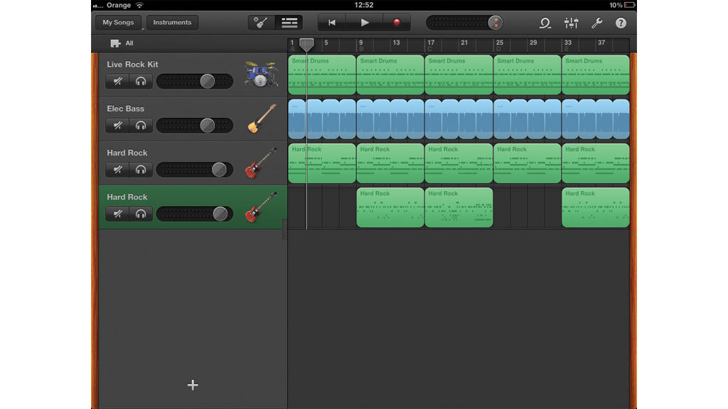**Recording More Tracks**

To add new tracks, tap **Track View**, tap the **+ sign** at the bottom left, and the **instrument** options will appear. Choose other **Touch Instruments** such as **Smart Bass**, **Smart Guitar**, **Smart Strings** and record the same chord progressions you started in Smart Keyboard. In Tracks View, hold the middle on the left side where your instruments are displayed and swipe right to open the **track controls** (mute, solo, volume). In the Instrument View, the **Playhead** (triangular marker on the ruler) can be used to mark the **starting point of recording**. You can rewind to move it to the start, or tap on the numbered **ruler** to choose a specific bar/beat. Once you are satisfied with every aspect, tap **Record (red dot, top middle).** Play the first section of the song and tap**Stop** when you are done. You can save time if the section you recorded is a repeated riﬀ or ostinato by looping or copying/pasting it as much as you like. You can **listen** to the recorded section by moving the **Playhead** to start of section and if you don’t like what you hear, you can always tap **Undo. You can add and record new tracks (new drum grooves, new chord progression) for different sections of your song (choruses, bridge, instrumental solo). The Touch instruments will be coloured green in the Track View.**

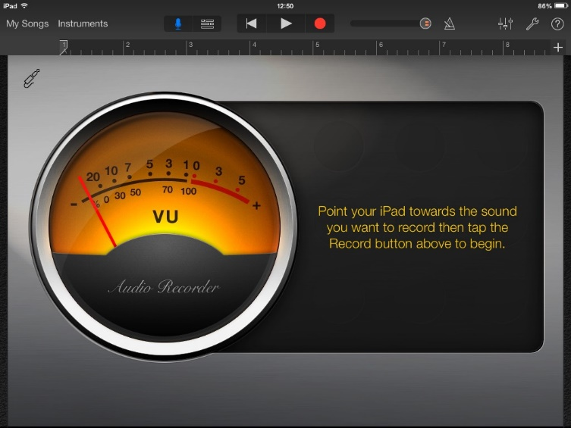**Audio Recorder**

**You may choose to record voice or any other sound by choosing Audio Recorder. Tap the Input Settings button (cable icon) and you can adjust input level, turn the monitor on to hear sound from an external microphone as you record, or set the noise gate level for reducing input noise.** Set your **Play head** where you wish to begin recording and tap the **Record** button to start and press **Stop** when you are done recording. You can choose from a variety of **preset effects** that appear after you record. Each adds an interesting character to the recorded sound. Try out different ones by tapping them and adjusting the sliders. Audio tracks will appear **purple** in the Tracks View.

**Guitar Amp**

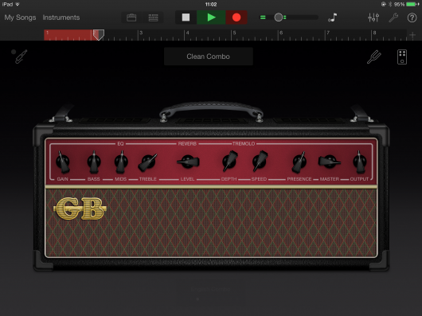You may choose to plug in an **electric guitar**, using an **interface** (e.g., *iRig 2* or Focusrite iTrack) and play through a variety of classic **amplifiers** (clean, crunchy, distorted, processed) and **stompboxes** (effects pedals). In **Track View**, tap the **+ sign** to add a new track, choose **Guitar Amp**, and click the default **Clean Combo** to open the amp options. Tap the **Stompboxes** button (rectangular, top right), choose from the existing boxes, or tap an empty slot to add more boxes. You can tune your guitar with the **tuner** (left of the Stompboxes button). Similar to the Audio Recorder, you can adjust **input settings** (cable icon), and the track will appear **purple** in the **Tracks View**.

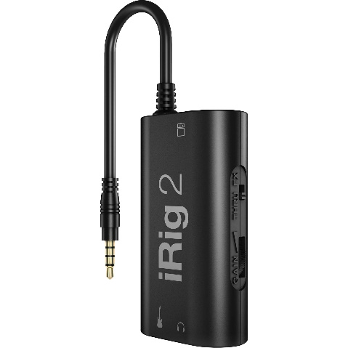

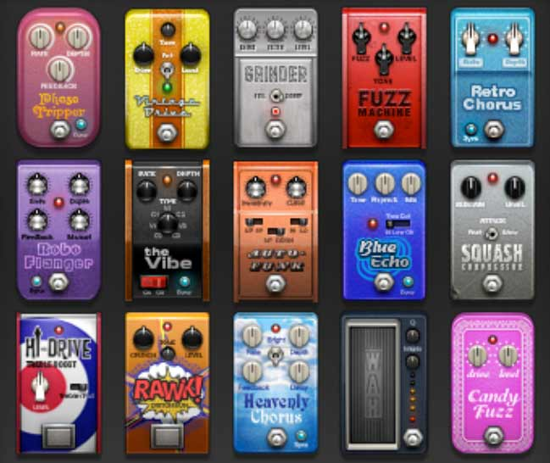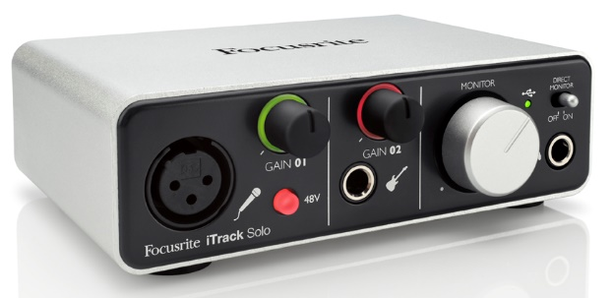

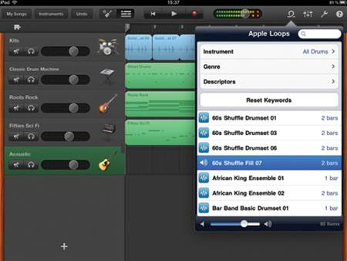**Apple Loops**

In the **Tracks View**, tap the **Loops Browser** button (circle, top right, next to the metronome). Tap **Instrument** and choose one. The **drums** or **kits** loops will be more useful to add to your existing recorded tracks. Tap to preview each loop, and drag a desired loop from the menu into your Tracks View. It will create a new track and be consistent with your chosen tempo.

***STEP 4* (Revising/Refining)**

**Editing Your Song**

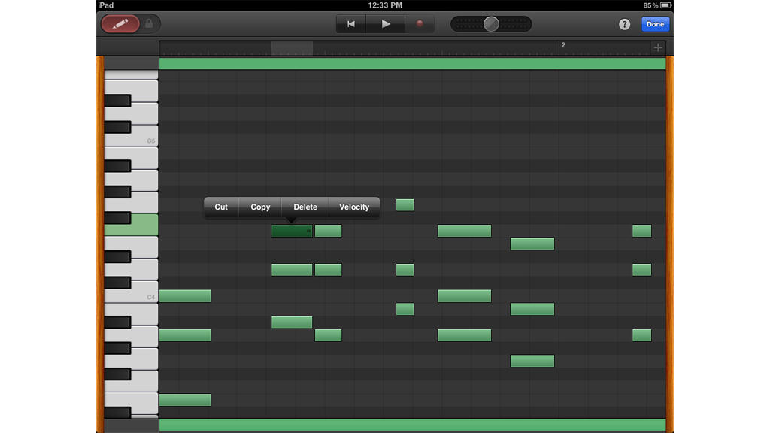In **Track** View, tap a **single region**. You can also select **multiple regions** by tapping and holding on any single region, and then as you constantly press on the section, you can use subsequent finger taps toselect other regions.

To use the selected region as a **loop** throughout the length of the song, double-tap a region to bring up the **Edit Menu**, tap **Loop**, and shorten or lengthen the loop by dragging the ends of the region in or out. You can also copy and paste a region anywhere in your track using the Edit menu by choosing**Copy**, navigating the Playhead to the start of the destination bar, double-tapping the empty space, and choosing **Paste** from theEdit Menu. You can also **cut**, **delete**, **join** or **split** regions.

After you are done editing regions, you may choose to modify any single note in the tracks (except drums) by entering the **Note Editor**. Double-tap a region to bring up the **Edit menu**, then tap **Edit**. There you can access a **keyboard** or **fret board** on the left side, drag notes to move them, cut, copy, delete, and adjust velocity. You can also **add or delete notes** by tapping the pen icon at the top left corner, and tapping in the editor. Tap **Done** when you are finished editing.

***STEP 5*** (**Presenting, Performing & Sharing)**

**Sharing created files from GarageBand**

Return to the Main Menu by tapping on the **My Songs button**. Tap and hold your song icon or tap **Select** (top right), creating your icon to wobble and a few new buttons appear near the **top left corner**.

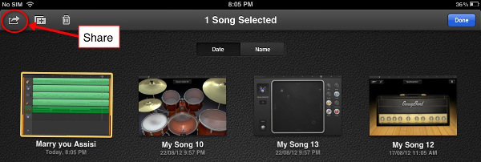

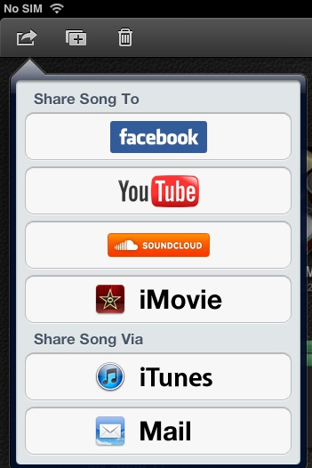Tap on the **Share button** (curved arrow in a box) and various options appear for sharing your music. You may upload it to Facebook, YouTube, SoundCloud, or iMovie, or share via iTunes or email. Once you have it uploaded, you may also choose to share it through other cloud services not listed, such as Google Drive, iCloud Drive, OneDrive, or Dropbox.

**Share, Export or Import to iTunes**

You can access your GarageBand for iPad files from your iTunes on your PC or Mac.

**iTunes:** When you choose iTunes from the two options that show up in the Share menu, **your track will be converted** into an audio format, which can then be played in iTunes, Windows Media Player, or any other music player. You can further edit this single layered track with software such as Audacity, Pro Tools, GarageBand, Logic, Mixcraft, Acid Music Studio, and so on, but you will **no longer** have separate instrument track layers as laid out in GarageBand since all the original layers will be merged into one single audio file.

**GarageBand:** This option is particularly advantageous for users with a PC or Mac running a desktop version of GarageBand. This method will preserve all the track layers and effects, which can be further edited or enhanced on the desktop version of GarageBand. After you decide and choose any of the options above, you can**retrieve your file from your desktop** via iTunes.

**ONLINE TUTORIALS AND ARTICLES**

### [**GarageBand for iPad Guide - Midnight Music**](http://www.midnightmusic.com.au/wp-content/uploads/2013/08/GarageBand-for-iPad-2013.pdf)

http://www.midnightmusic.com.au/wp-content/uploads/2013/08/GarageBand-for-iPad-2013.pdf

* **Apple GarageBand for iPad Manual**

http://help.apple.com/garageband/ipad/1.2/index.html

* **5 Essential Workflow Tips for GarageBand for iPad**

http://www.macprovideo.com/hub/garageband-ilife-2/5-essential-tips-garageband-ipad

# **Extensive GarageBand Tutorial**

# http://www.ipadable.com/extensive-garageband-ipad-tutorial/

**COMPOSITION USING GARAGEBAND - REFLECTION**

When you were composing your song, did you approach rhythm or melody first? What aspect of the composition do you approach next? Why?

How did you decide whether your experiments with changing certain musical elements such as instrument sounds, time signature, rhythmic patterns, melodies, chords, and dynamics have been successful?

What was the most effective way of recording an audio track (e.g., vocal or guitar) for your composition?

Which functions in GarageBand are similar to those in other software programs, such as word processing programs?

Explain what went well in the creative process of composing your song.

Explain what did not go well in the creative process of composing your song.

In what ways did feedback from your peers or teacher influence how you have refined your composition?

**COMPOSITION USING GARAGEBAND – EVALUATION**

Name _________________________ Composition Title _______________________________**__**

|  |  |  |  |  |
| --- | --- | --- | --- | --- |
| **CATEGORIES** | **LEVEL 1** | **LEVEL 2** | **LEVEL 3** | **LEVEL 4** |
| **KNOWLEDGE/UNDER-STANDING**   * Understanding of the musical elements as they pertain to your composition   Knowledge of the GarageBand app | Incorporates musical elements with limited effectiveness; shows limited understanding of the basic functions in the GarageBand app | Incorporates musical elements with some effectiveness; shows some understanding of the basic functions in the GarageBand app | Incorporates musical elements considerable effectiveness; shows considerable understanding of the basic functions in the GarageBand app | Incorporates musical elements with a high degree of effectiveness; shows a high degree of understanding of the basic functions in the GarageBand app and explores advanced functions |
| **THINKING/INQUIRY**   * Creative thinking and independent, self-directed problem-solving skills * Inventiveness, flexibility, divergent thinking, and originality used to fulfill parameters of the composition * Use of creative process | Uses creative thinking and problem solving skills with limited effectiveness and originality; demonstrates limited preplanning; shows little evidence of revising and refining | Uses creative thinking and problem solving skills with some effectiveness and originality; demonstrates some preplanning; shows evidence of some revising and refining | Uses creative thinking and problem solving skills with considerable effectiveness and originality; demonstrates considerable preplanning; shows considerable evidence of revising and refining | Uses creative thinking and problem solving skills with thorough and insightful effectiveness and originality; demonstrates thorough preplanning; shows complete evidence of revising and refining |
| **COMMUNICATION**   * Expression of ideas * Explanation of the composition in terms of use of musical elements * Personal reflection | Communicates and reflects on work with limited clarity, depth, and precision in explaining the use of musical elements in the composition | Communicates and reflects on work with some clarity, depth, and precision in explaining the use of musical elements in the composition | Communicates and reflects on work with considerable clarity, depth, and precision in explaining the use of musical elements in the composition | Communicates and reflects on work with thorough and insightful clarity, depth, and precision in explaining the use of musical elements in the composition |
| **APPLICATION**   * Control of technical skill in using the GarageBand app for sequencing, looping and recording * Meeting requirements in creating the composition | Limited control of technical skill in using the GarageBand app for sequencing, looping and recording;  Meets little of the requirements in creating the composition | Some control of technical skill in using the GarageBand app for sequencing, looping and recording;  Meets some requirements in creating the composition | Considerable control of technical skill in using the GarageBand app for sequencing, looping and recording;  Meets most of the requirements in creating the composition | Thorough and insightful control of technical skill in using the GarageBand app for sequencing, looping and recording;  Meets all of the requirements in creating the composition and shows extensions beyond the requirements |

**Comments:**

**TOTAL: ____ /**